**CS634 Data Mining**

**Implementation Project**

**-Alfred Zane Rajan Velladurai**

**UCID: ar2257**

**Platforms:**

Programming language: Python

IDE: Spyder

Operating System: Windows

Hardware: Laptop

**Source Code:**

import urllib

from bs4 import BeautifulSoup

import urllib.request

import re

#%%

data = "DataMining.txt"

#%%

k = 200

IN = open(data)

base = list()

line = IN.readline()

while line != '':

a = line.split()

base.append(a[0])

line = IN.readline()

IN.close()

nbrhd = [page for page in base]

n = 30

b = 0

adj = {}

for page in base:

b+=1

try:

resp = urllib.request.urlopen(page)

except urllib.error.HTTPError as e:

continue

except urllib.error.URLError as e:

continue

adj[b] = set()

c = 0

soup = BeautifulSoup(resp, from_encoding=resp.info().get_param('charset'))

for link in soup.find_all('a', href=True):

lnk = link['href']

if re.search("^http", lnk):

if lnk not in nbrhd:

nbrhd.append(lnk)

n+=1

adj[b].add(n)

else:

t = nbrhd.index(lnk) + 1

adj[b].add(t)

c+=1

if c > k/30:

break

#%%

n = -1

adj = {}

for page in nbrhd:

n+=1

try:

resp = urllib.request.urlopen(page)

except urllib.error.HTTPError as e:

if e.code in (..., 403, ...):

continue

except urllib.error.URLError as e:

continue

adj[n] = set()

soup = BeautifulSoup(resp, from_encoding=resp.info().get_param('charset'))

for link in soup.find_all('a', href=True):

lnk = link['href']

if re.search("^http", lnk):

if lnk in nbrhd and lnk != page:

t = nbrhd.index(lnk)

adj[n].add(t)

#%%

for edges in adj:

adj[edges] = list(adj[edges])

#%%

Itr = 10

vert = len(nbrhd)

auth = []

hub = []

for i in range(vert):

auth.append(1)

hub.append(1)

for itr in range(Itr):

auth = [0 for a in auth]

for u in adj:

for v in adj[u]:

auth[v] += hub[u]

norm = 0

for a in auth:

norm += a**2

norm = norm**0.5

auth = [a/norm for a in auth]

hub = [0 for h in hub]

norm = 0

for u in adj:

for v in adj[u]:

hub[u] += auth[v]

norm += hub[u]**2

norm = norm**0.5

hub = [h/norm for h in hub]

#%%

N = 10

au = {}

for i in range(vert):

au[i] = auth[i]

print("The top " + str(N) + " Authority weights are for the following websites:")

print("Authority Weight \t Hub Weight \t\t Website")

for n in range(N):

m = max(au, key=lambda key: au[key])

au.pop(m)

print(str(auth[m]) +'\t'+ str(hub[m]) +'\t'+ nbrhd[m])

#%%

hu = {}

for i in range(vert):

hu[i] = hub[i]

print("The top " + str(N) + " Hub weights are for the following websites:")

print("Hub Weight \t\t Authority Weight \t Website")

for n in range(N):

m = max(hu, key=lambda key: hu[key])

hu.pop(m)

print(str(hub[m]) +'\t'+ str(auth[m]) +'\t'+ nbrhd[m])

#%%

for page in nbrhd:

print(page)

try:

resp = urllib.request.urlopen(page)

except urllib.error.HTTPError as e:

if e.code in (..., 403, ...):

print("\n\n")

continue

except urllib.error.URLError as e:

print("\n\n")

continue

soup = BeautifulSoup(resp, from_encoding=resp.info().get_param('charset'))

try:

print(soup.find('p').get_text())

except AttributeError as e:

print("\n\n")

continue

print("\n\n")

**Description:**

The program reads the base set of 30 pages from a txt file written manually. The source code then crawls those pages for links to further pages and looks for connections between these pages. Using these discovered edges an adjacency list is created.

Later from this adjacency list we implement the HITS algorithm to get the auth score and hub score iteratively until they converge.

We then have separate sections to printout the top authority scores, the top hub scores and also the whole neighbourhood graph URLs.

Let us now see the code in action for a maximum neighbourhood size of 300.

**k = 300:**

We first take the 30 websearch results for “Data Mining” and crawl through those 30 pages to get the links for our neighbourhood graph.

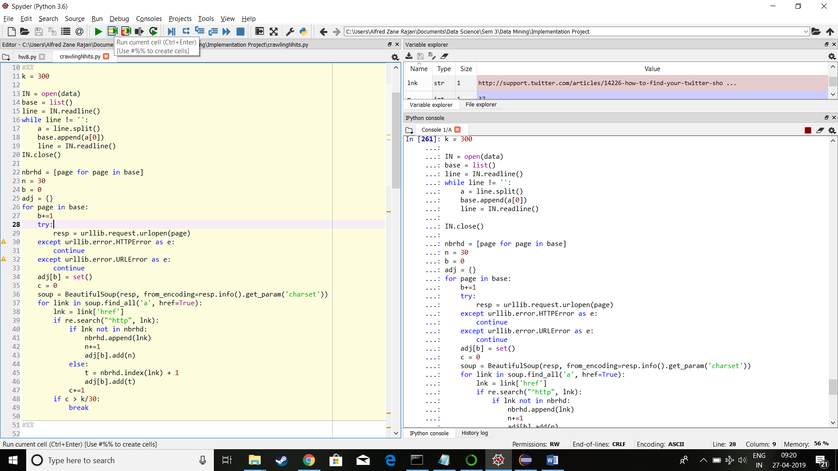

We get the following list of URLs

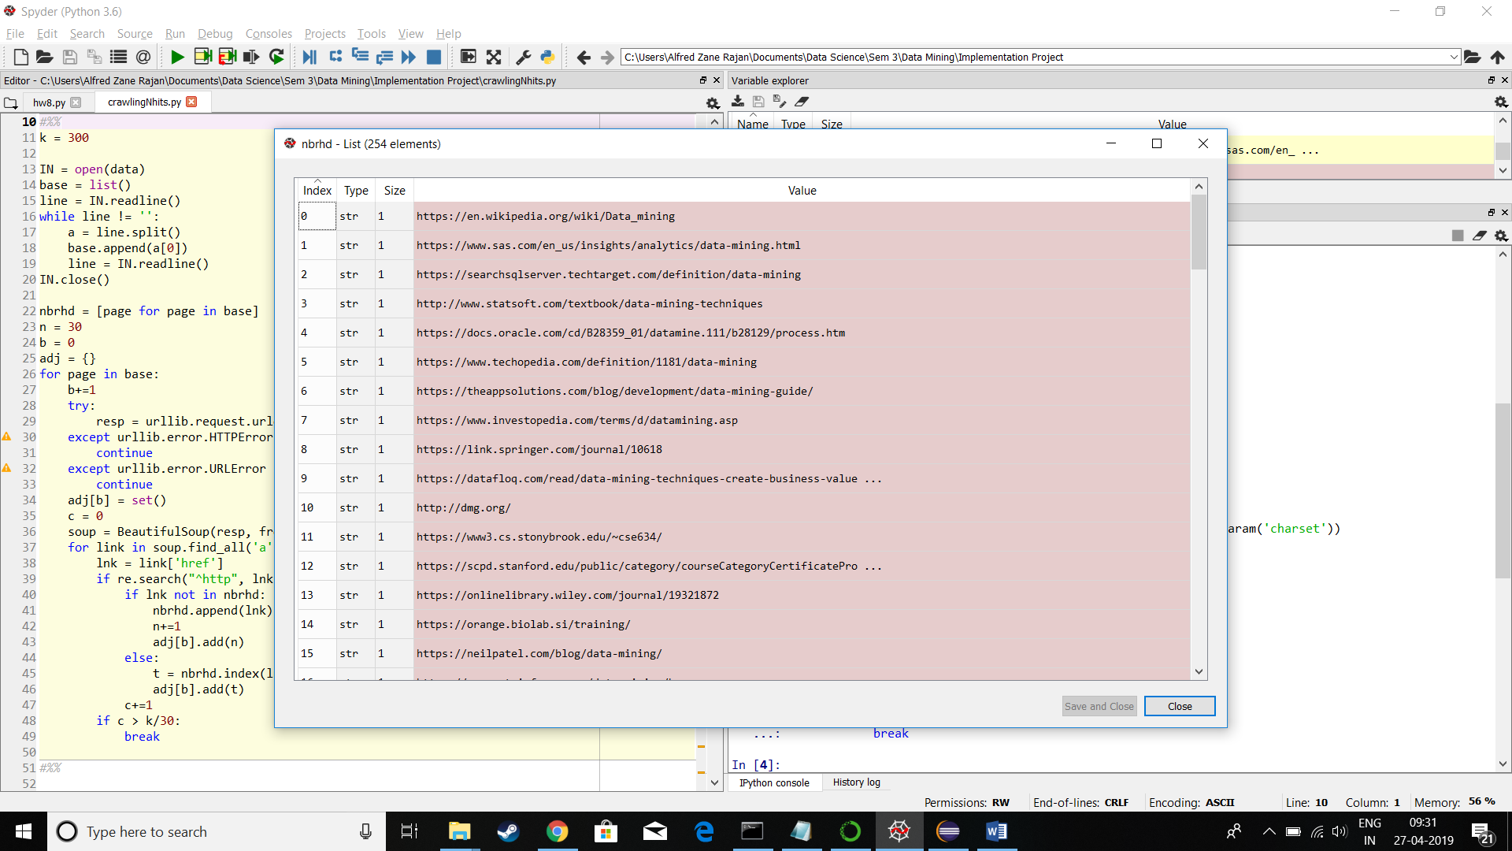

Next we crawl through all the URLs in the neighbourhood graph inorder to find pages that link to one another and we simultaneously create an adjacency list.

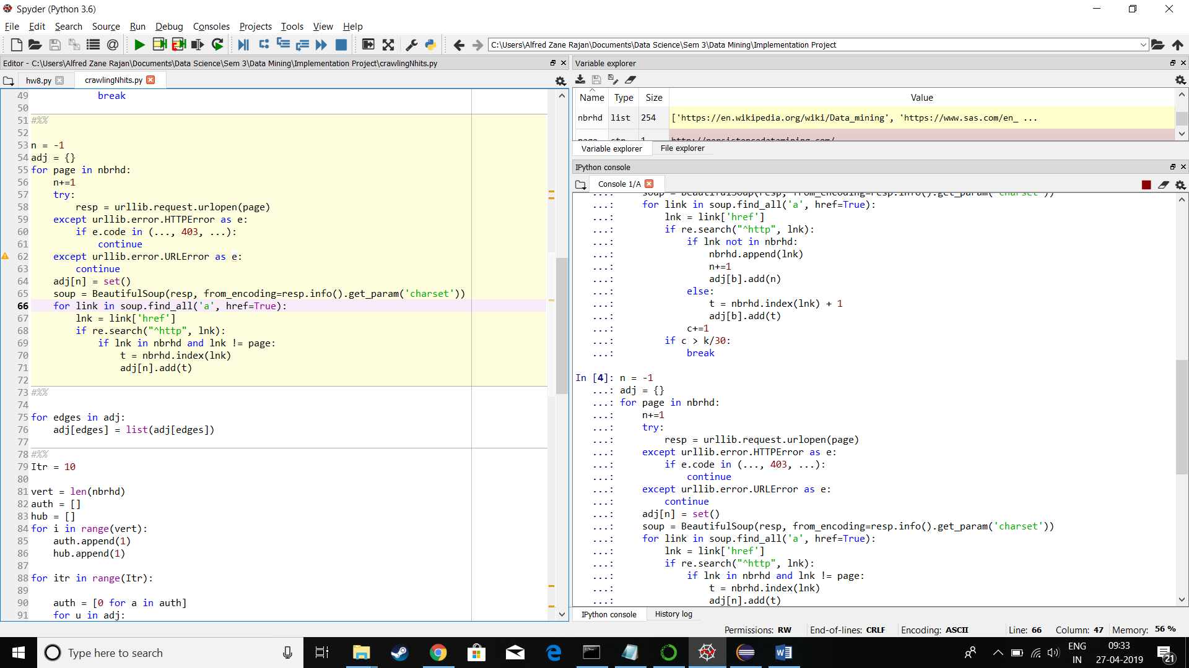

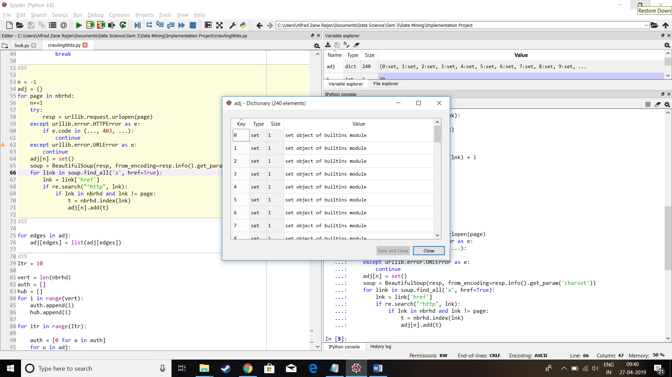

We use a dictionary of sets to avoid repetitions of edges. We then convert in to dictionary of lists for further use.

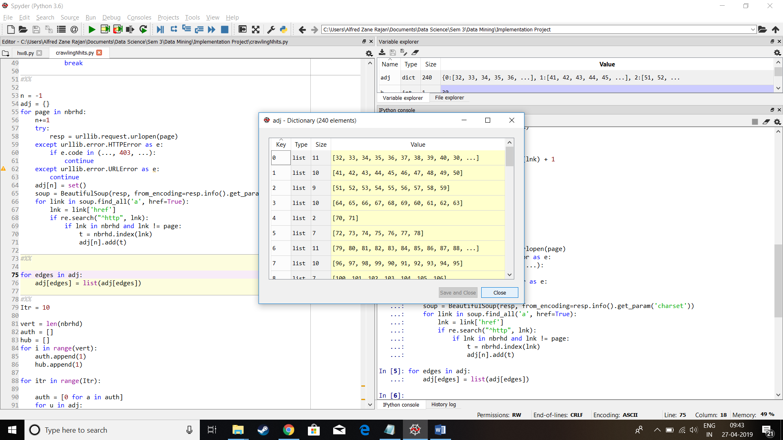

This is our adjacency list.

We next calculate the authority weights and hub weights iteratively until they converge.

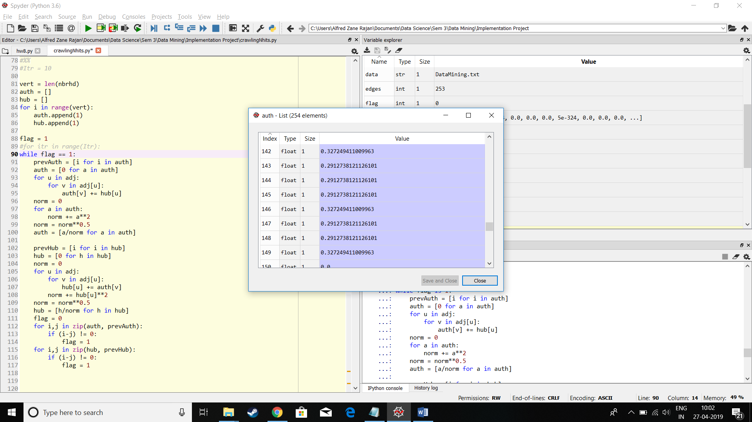

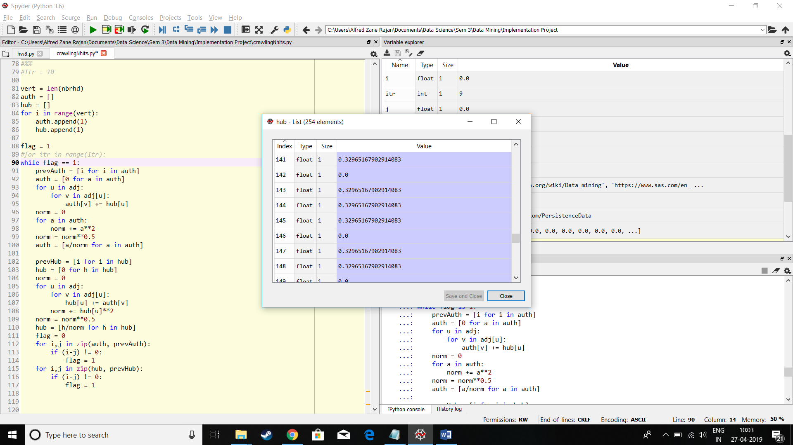

Now we have the Authority weights and the Hub weights. So we can proceed to printing out the top weights.

**N = 5**

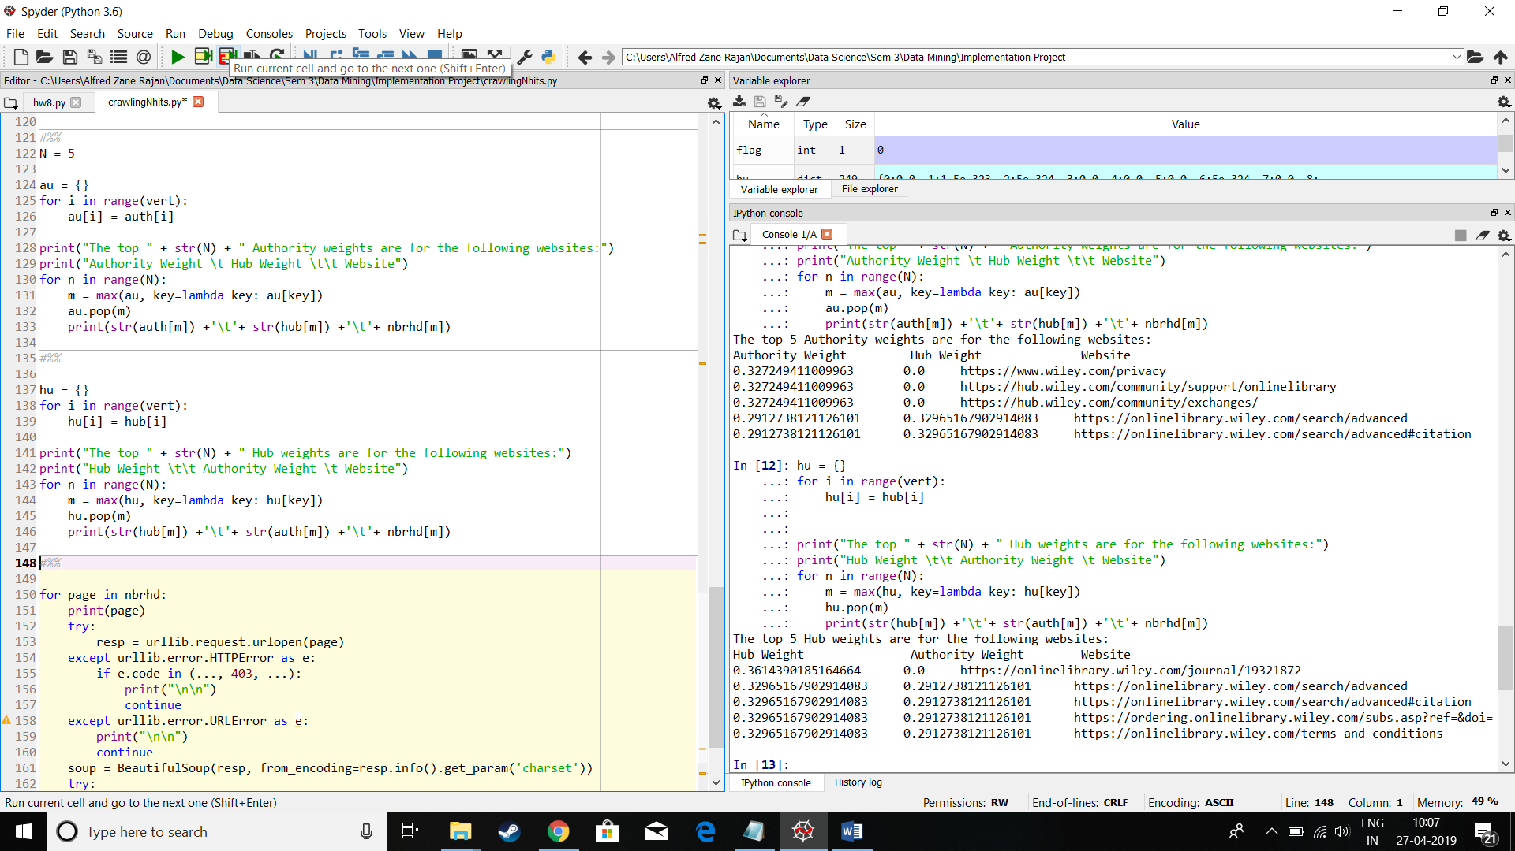

**N = 10**

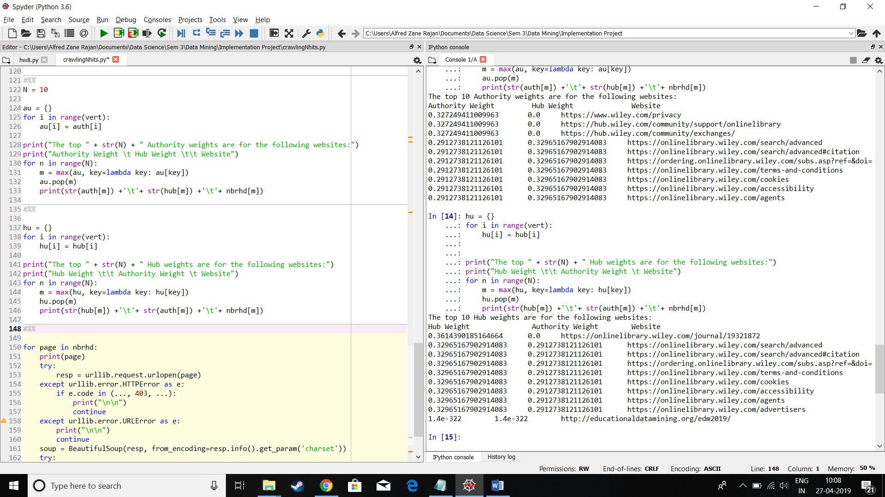

**N = 20**

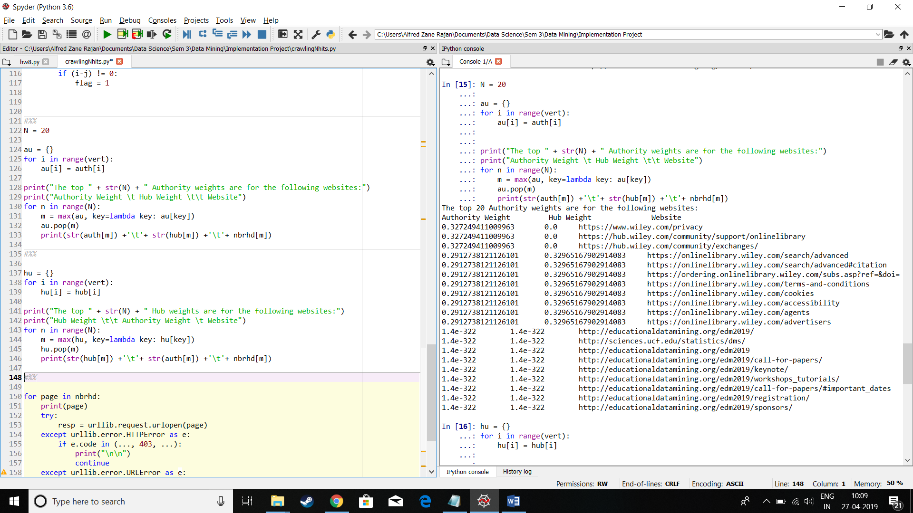

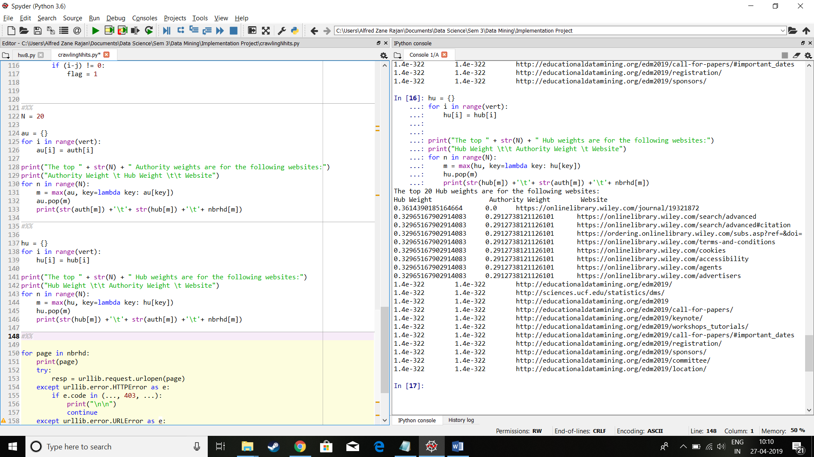

**We can now witness the printing out of all the pages in the neighbourhood graph.**

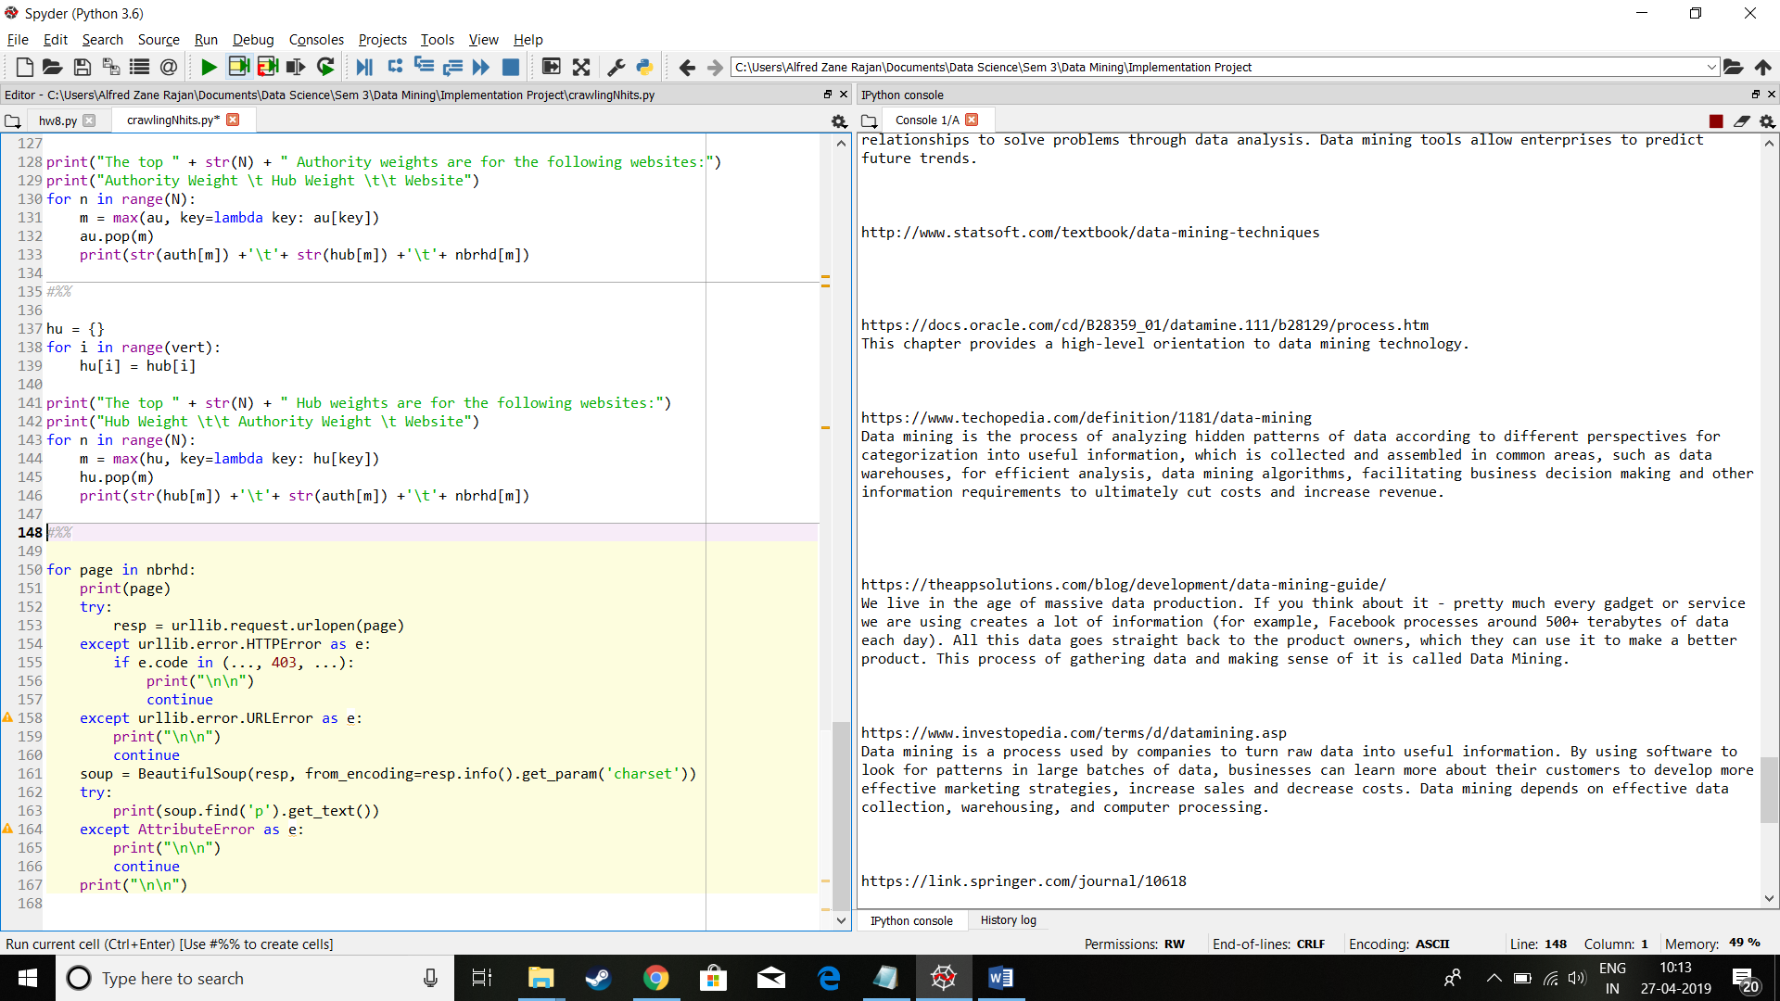

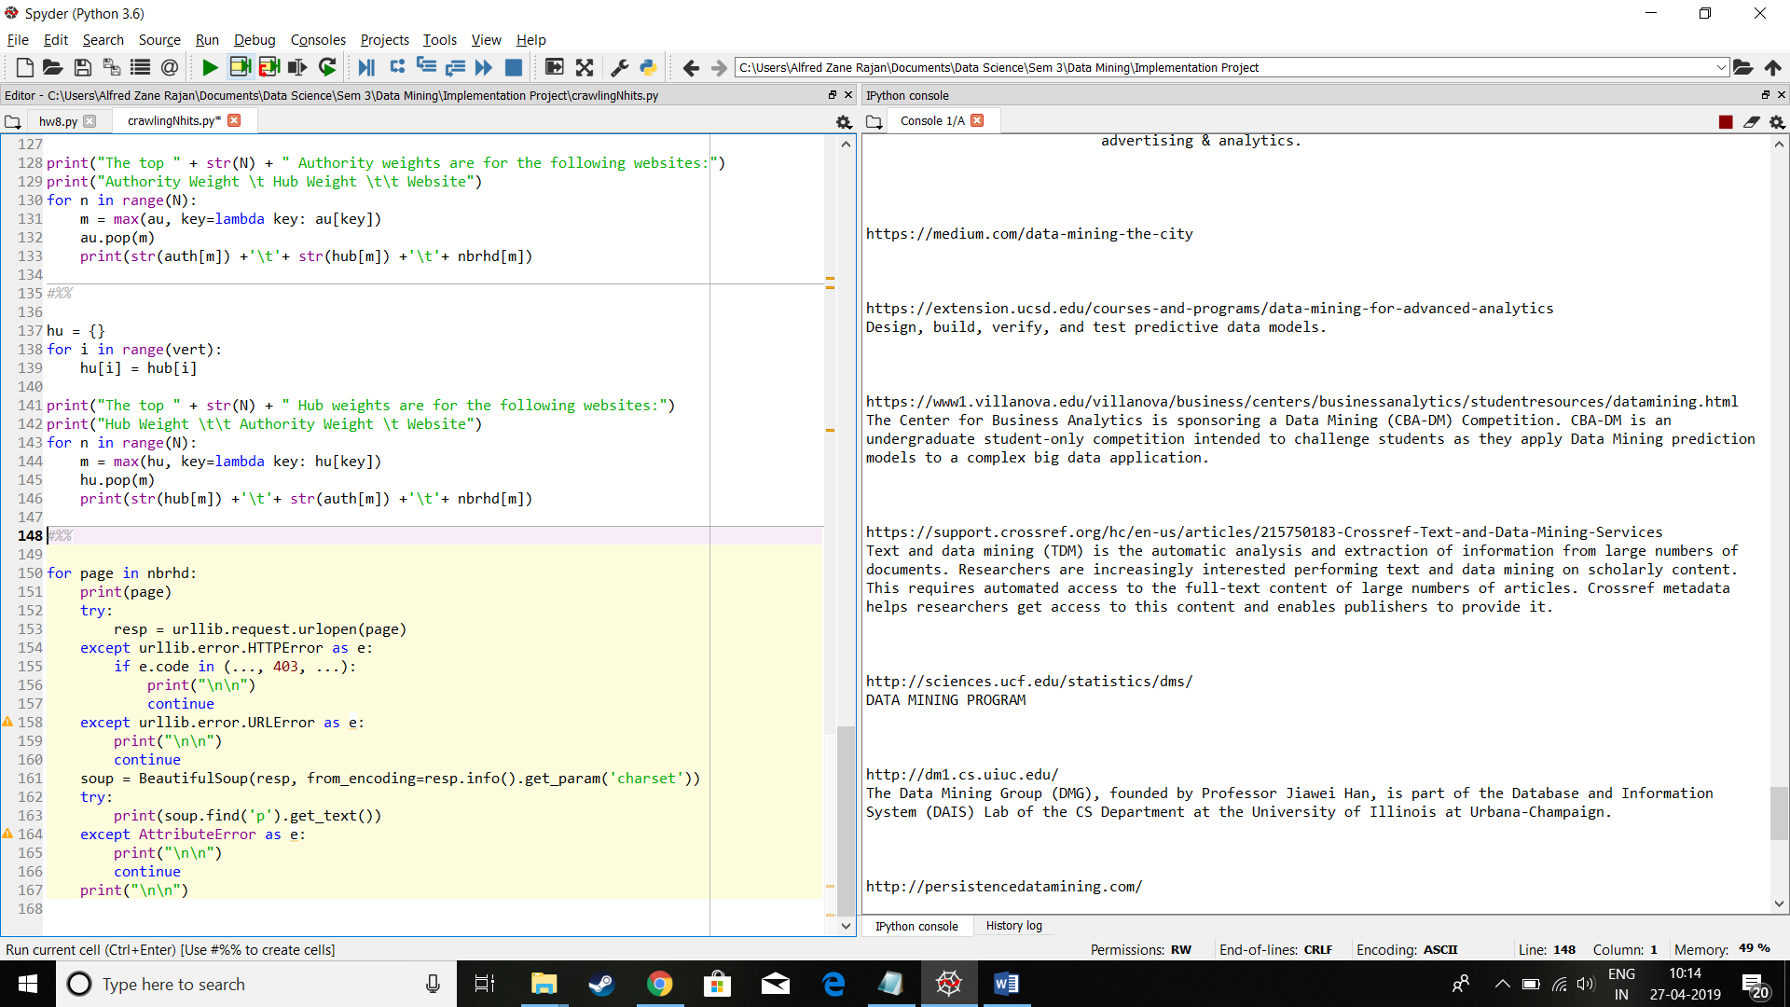

Above are just a couple samples. I will be dumping the whole output at the end of the file if size permits.

**Now in similar fashion we find the top 10 authority and hub weights for other web search results:**

**Machine Learning:**

**K = 300**

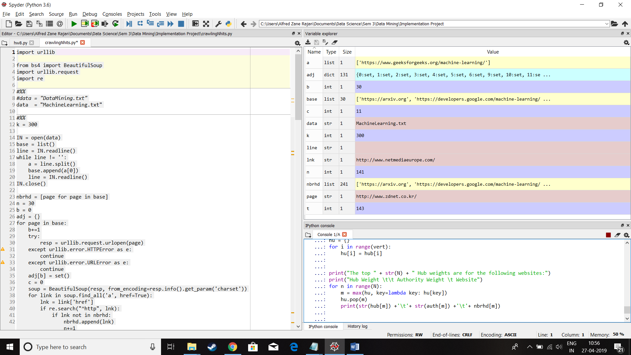

N = 10

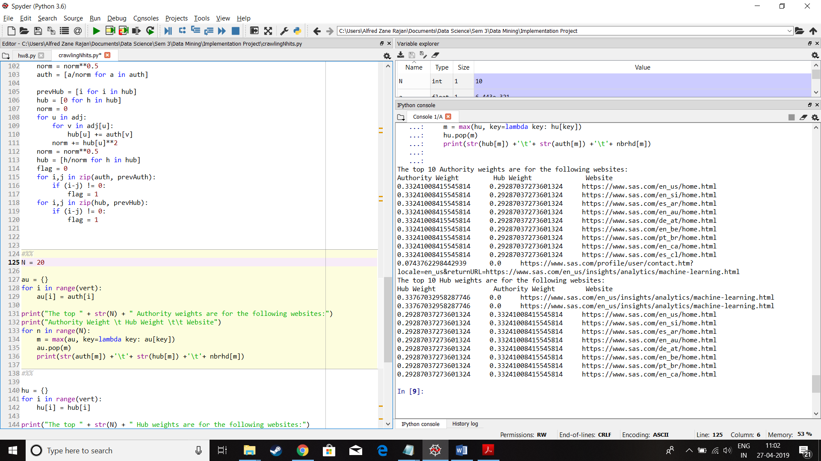

**Deep Learning:**

This dataset unfortunately took too long to converge to zero change. So a tolerance of 10-5 was allowed.

for i,j in zip(auth, prevAuth):

if abs(i-j) > 10**-5:

flag = 1

for i,j in zip(hub, prevHub):

if abs(i-j) > 10**-5:

flag = 1

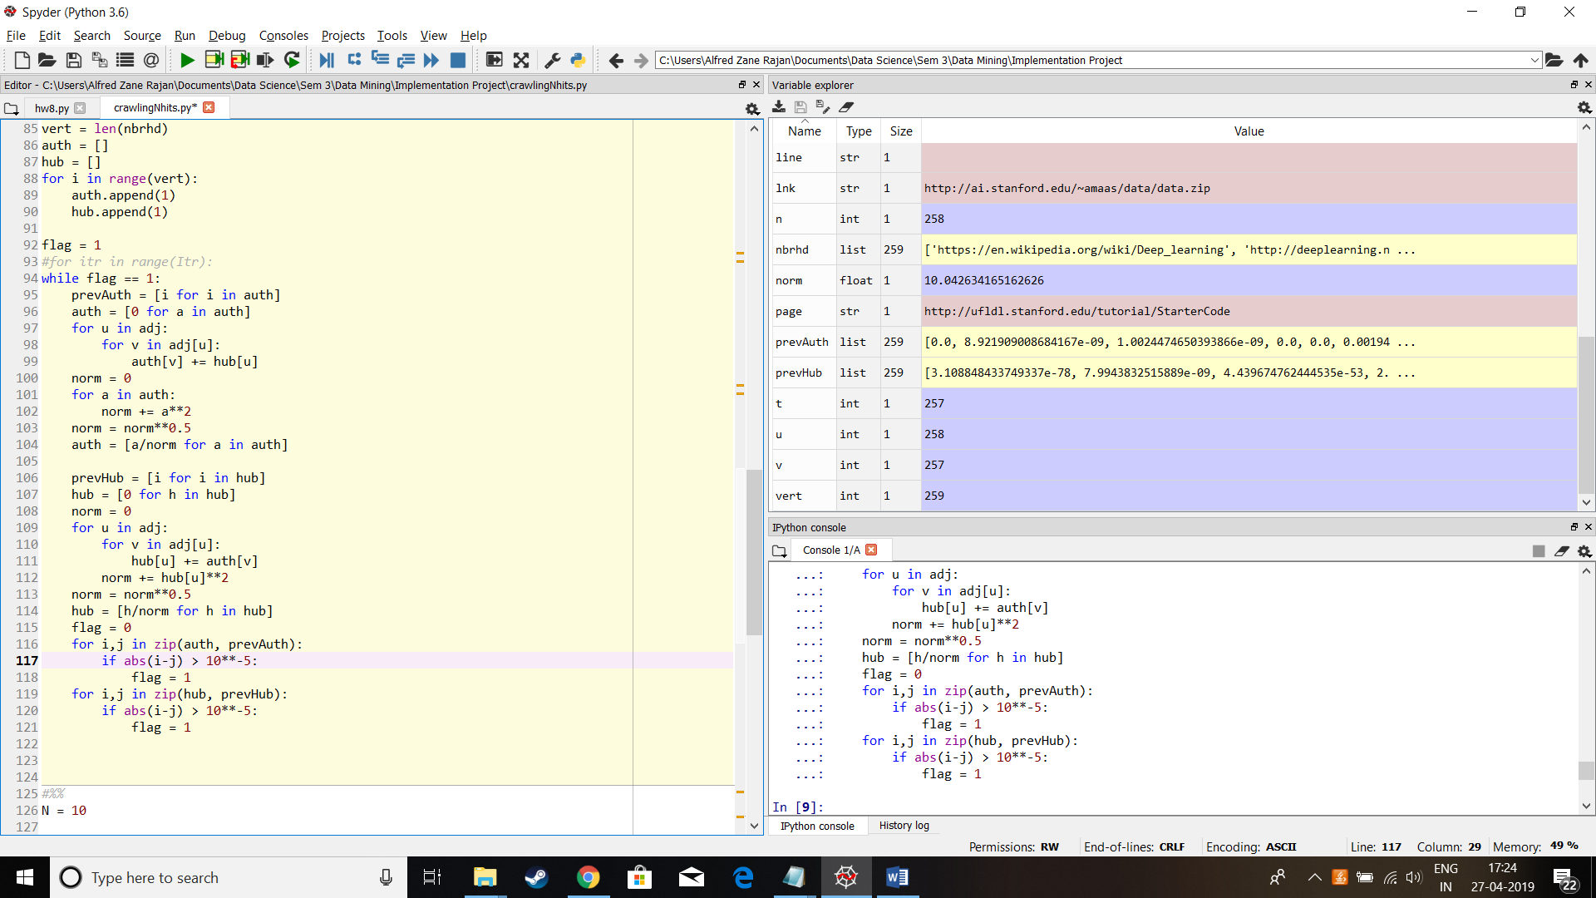

**N = 20**

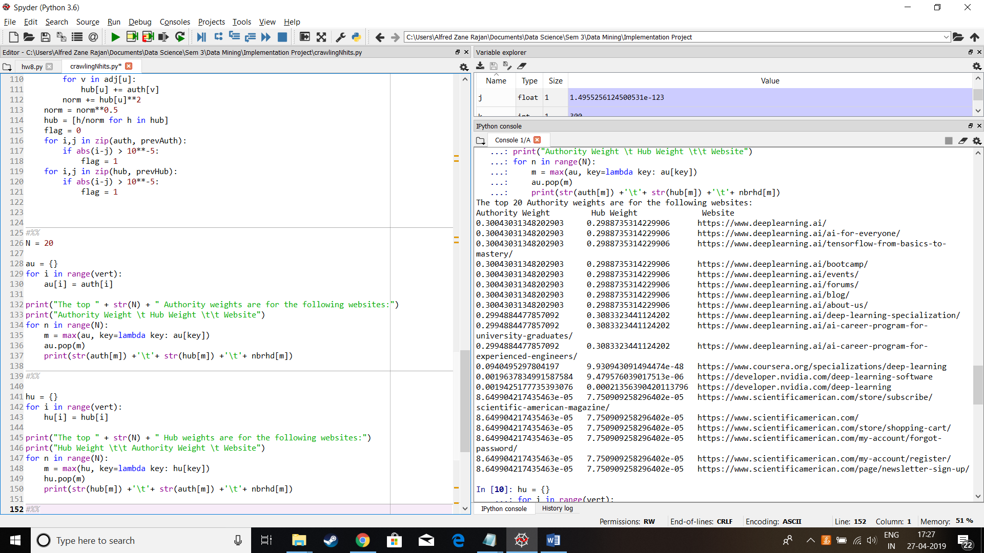

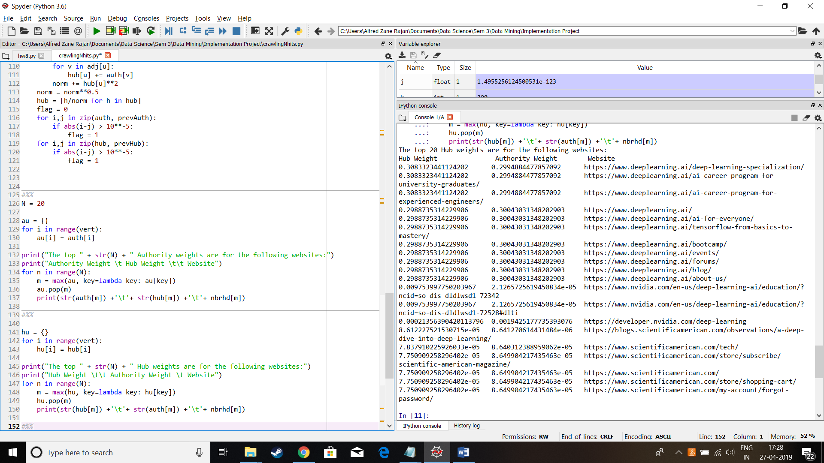

Here we see that due to our tolerance, the weights did not get as low as in previous cases.

**Big Data Analytics:**

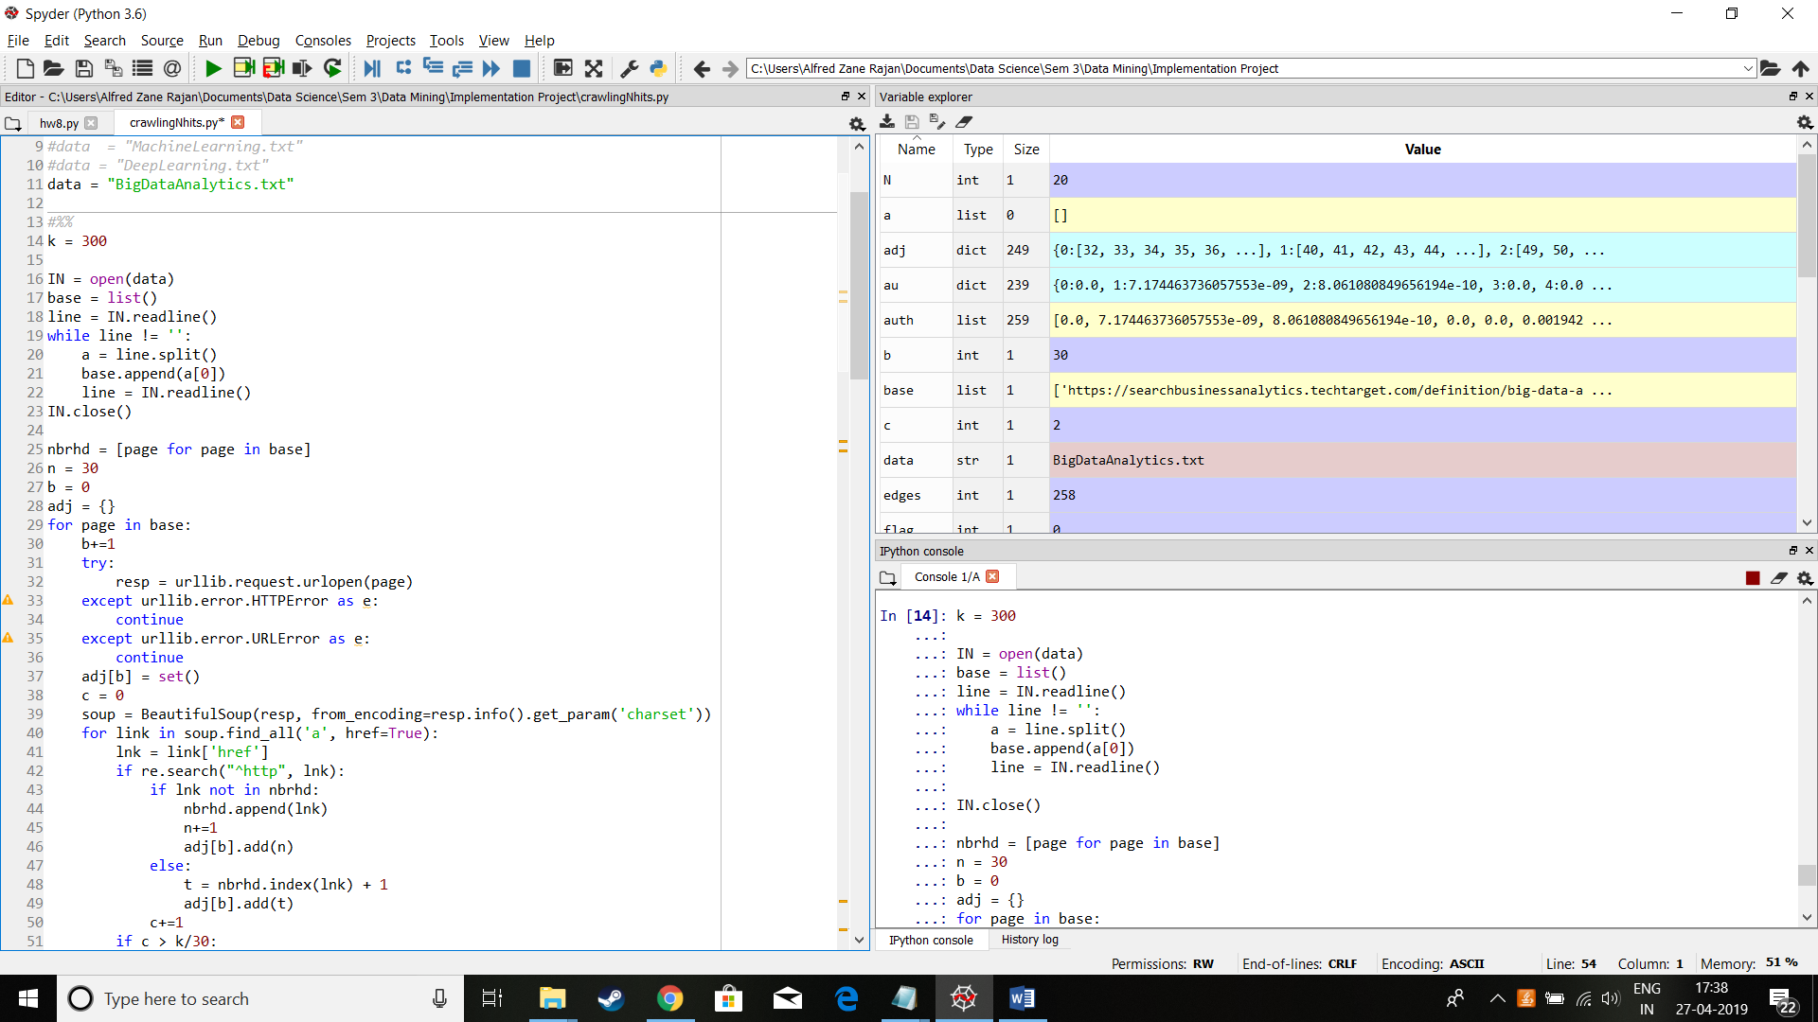

**N = 10**

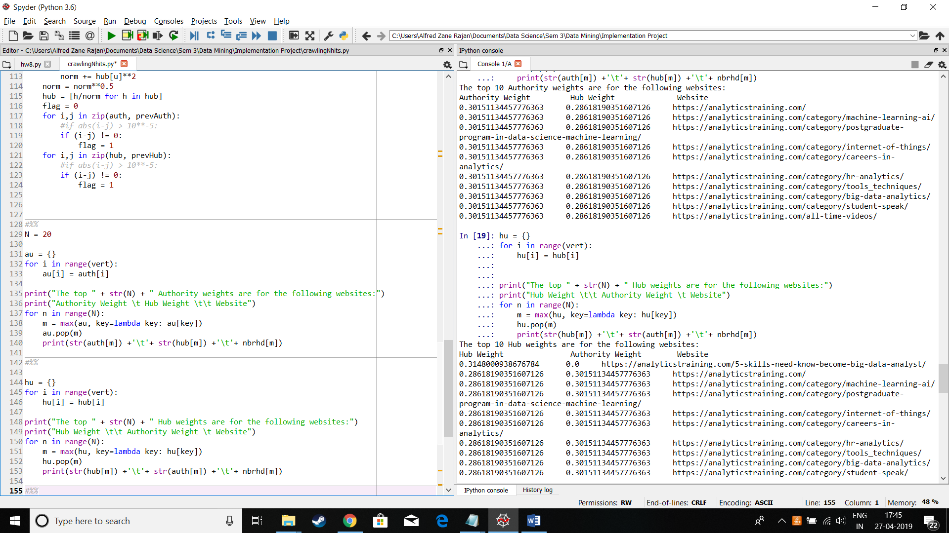

Here I will dump the data too big and shabby to allow a clear report

**“Data Mining” root set:**

https://en.wikipedia.org/wiki/Data_mining

https://www.sas.com/en_us/insights/analytics/data-mining.html

https://searchsqlserver.techtarget.com/definition/data-mining

http://www.statsoft.com/textbook/data-mining-techniques

https://docs.oracle.com/cd/B28359_01/datamine.111/b28129/process.htm

https://www.techopedia.com/definition/1181/data-mining

https://theappsolutions.com/blog/development/data-mining-guide/

https://www.investopedia.com/terms/d/datamining.asp

https://link.springer.com/journal/10618

https://datafloq.com/read/data-mining-techniques-create-business-value/121

http://dmg.org/

https://www3.cs.stonybrook.edu/~cse634/

https://scpd.stanford.edu/public/category/courseCategoryCertificateProfile.do%3Fmethod%3Dload%26certificateId%3D1209602

https://onlinelibrary.wiley.com/journal/19321872

https://orange.biolab.si/training/

https://neilpatel.com/blog/data-mining/

https://connect.informs.org/data-mining/home

http://educationaldatamining.org/edm2019/

https://rapidminer.com/data-mining-tools-try-rapidminer/

https://store.steampowered.com/app/993630/Data_mining_4/

http://guidetodatamining.com/

https://inhomelandsecurity.com/fake-news-data-mining/

https://thenextweb.com/gaming/2019/03/15/gamers-epic-games-rift-data-mining-tencent/

https://medium.com/data-mining-the-city

https://extension.ucsd.edu/courses-and-programs/data-mining-for-advanced-analytics

https://www1.villanova.edu/villanova/business/centers/businessanalytics/studentresources/datamining.html

https://support.crossref.org/hc/en-us/articles/215750183-Crossref-Text-and-Data-Mining-Services

http://sciences.ucf.edu/statistics/dms/

http://dm1.cs.uiuc.edu/

http://persistencedatamining.com/

**“Machine Learning” root set:**

https://arxiv.org

https://developers.google.com/machine-learning/crash-course/

https://en.wikipedia.org/wiki/Machine_learning

https://cloud.google.com/products/ai/

https://xkcd.com/1838/

https://aws.amazon.com/machine-learning/

https://www.wired.com/tag/machine-learning/

https://developer.apple.com/machine-learning/

https://towardsdatascience.com/machine-learning/home

https://searchenterpriseai.techtarget.com/definition/machine-learning-ML

https://azure.microsoft.com/en-us/services/machine-learning-service/

https://www.brookings.edu/research/what-is-machine-learning/

https://www.sas.com/en_us/insights/analytics/machine-learning.html

https://www.zdnet.com/article/what-is-machine-learning-everything-you-need-to-know/

https://www.forbes.com/.../20-examples-of-machine-learning-used-in-customer-experi

https://emerj.com

https://www.edx.org/learn/machine-learning

https://www.mathworks.com/discovery/machine-learning.html

https://www.youtube.com/watch?v=ukzFI9rgwfU

https://www.ml.cmu.edu/

https://royalsociety.org/topics-policy/projects/machine-learning/

https://www.sap.com/products/leonardo/machine-learning.html

https://www.elastic.co/products/stack/machine-learning

https://www.udemy.com/topic/machine-learning/

https://medium.com/machine-learning.../why-machine-learning-matters-6164faf1df12

https://www.sas.com/en_us/insights/analytics/machine-learning.html

https://www.expertsystem.com/machine-learning-definition/

https://www.coursera.org/learn/machine-learning

https://www.udacity.com/course/intro-to-machine-learning--ud120

https://www.geeksforgeeks.org/machine-learning/

**“Deep Learning” root set:**

['https://en.wikipedia.org/wiki/Deep_learning',

'http://deeplearning.net/',

'https://www.mathworks.com/discovery/deep-learning.html',

'https://www.udacity.com/course/intro-to-tensorflow-for-deep-learning--ud187',

'https://machinelearningmastery.com/what-is-deep-learning/',

'https://developer.nvidia.com/deep-learning',

'https://www.forbes.com/sites/bernardmarr/2018/10/01/what-is-deep-learning-ai-a-simple-guide-with-8-practical-examples/',

'https://skymind.ai/wiki/neural-network',

'http://neuralnetworksanddeeplearning.com/chap6.html',

'https://www.investopedia.com/terms/d/deep-learning.asp',

'https://www.technologyreview.com/s/513696/deep-learning/',

'https://www.coursera.org/specializations/deep-learning',

'https://www.deeplearningbook.org/',

'https://searchenterpriseai.techtarget.com/definition/deep-learning-deep-neural-network',

'https://www.sas.com/en_us/insights/analytics/deep-learning.html',

'https://medium.com/tensorflow/mit-introduction-to-deep-learning-4a6f8dde1f0c',

'https://www.edx.org/professional-certificate/ibm-deep-learning',

'https://www.udemy.com/deeplearning/',

'https://deeplearning.mit.edu/',

'https://aws.amazon.com/deep-learning/',

'https://www.ibm.com/cloud/deep-learning',

'https://blogs.scientificamerican.com/observations/a-deep-dive-into-deep-learning/',

'https://www.datacamp.com/courses/deep-learning-in-python',

'https://www.deeplearning.ai/',

'https://software.intel.com/en-us/ai/courses/deep-learning',

'https://www.nature.com/articles/s41576-019-0122-6',

'http://docs.h2o.ai/h2o/latest-stable/h2o-docs/data-science/deep-learning.html',

'https://towardsdatascience.com/detecting-malaria-with-deep-learning-9e45c1e34b60',

'https://course.fast.ai/',

'http://deeplearning.stanford.edu/tutorial/',

'https://arxiv.org/list/cs.LG/recent',

'http://adsabs.harvard.edu/abs/2015Natur.521..436L',

'http://ieeexplore.ieee.org/document/6248110/',

'https://www.cs.toronto.edu/~kriz/imagenet_classification_with_deep_convolutional.pdf',

'https://techcrunch.com/2017/05/24/alphago-beats-planets-best-human-go-player-ke-jie/amp/',

'http://adsabs.harvard.edu/abs/1996Natur.381..607O',

'http://research.microsoft.com/pubs/209355/DeepLearning-NowPublishing-Vol7-SIG-039.pdf',

'http://sanghv.com/download/soft/machine%20learning,%20artificial%20intelligence,%20mathematics%20ebooks/ML/learning%20deep%20architectures%20for%20AI%20%282009%29.pdf',

'http://www.scholarpedia.org/article/Deep_Learning',

'http://adsabs.harvard.edu/abs/2009SchpJ...4.5947H',

'http://deeplearning.net/reading-list/',

'http://deeplearning.net/reading-list/tutorials/',

'http://deeplearning.net/software_links/',

'http://deeplearning.net/blog/',

'http://deeplearning.net/demos/',

'http://deeplearning.net/datasets/',

'http://deeplearning.net/events/',

'http://deeplearning.net/bibliography/',

'http://deeplearning.net/deep-learning-research-groups-and-labs/',

'https://www.mathworks.com/matlabcentral/?s_tid=gn_mlc',

'https://www.mathworks.com/matlabcentral/fileexchange/60659-deep-learning-in-11-lines-of-matlab-code',

'https://www.mathworks.com/help/vision/examples/object-detection-using-deep-learning.html',

'https://www.mathworks.com/matlabcentral/fileexchange/?s_tid=hp_ff_p_fx',

'https://www.mathworks.com/downloads/web_downloads/?s_iid=hp_ff_t_downloads',

'https://www.mathworks.com/store?s_iid=hp_ff_t_buy',

'https://www.mathworks.com/help/?s_tid=hp_ff_l_doc',

'https://www.mathworks.com/support/learn-with-matlab-tutorials.html?s_tid=hp_ff_l_tutorials',

'https://www.mathworks.com/help/examples.html?s_tid=hp_ff_l_examples',

'https://www.mathworks.com/support/install-matlab.html?s_tid=hp_ff_s_install',

'https://auth.udacity.com/sign-in?next=https://classroom.udacity.com/authenticated',

'https://auth.udacity.com/sign-up?next=https://classroom.udacity.com/authenticated',

'https://www.udacity.com/tech-requirements',

'https://www.udacity.com/school-of-ai',

'https://www.udacity.com/school-of-autonomous-systems',

'https://www.udacity.com/school-of-business',

'https://www.udacity.com/school-of-data-science',

'https://www.udacity.com/school-of-programming',

'https://career-resource-center.udacity.com',

'https://news.developer.nvidia.com/',

'https://devblogs.nvidia.com/',

'https://devtalk.nvidia.com/',

'https://developer.nvidia.com/deep-learning-software',

'https://developer.nvidia.com/tensorrt',

'https://www.nvidia.com/en-us/deep-learning-ai/education/?ncid=so-dis-dldlwsd1-72342',

'https://courses.nvidia.com/courses/course-v1:DLI+C-FX-01+V2/about?ncid=so-dis-dldlwsd1-72346',

'https://www.nvidia.com/en-us/deep-learning-ai/education/?ncid=so-dis-dldlwsd1-72528#dlti',

'http://www.nvidia.com/object/legal_info.html',

'https://www.forbes.com/worlds-billionaires/',

'https://www.forbes.com/billionaires/',

'https://www.forbes.com/forbes-400/',

'https://www.forbes.com/self-made-women/',

'https://www.forbes.com/china-billionaires/',

'https://www.forbes.com/india-billionaires/',

'https://www.forbes.com/indonesia-billionaires/',

'https://www.forbes.com/korea-billionaires/list/',

'https://www.forbes.com/thailand-billionaires/list/ ',

'https://www.forbes.com/japan-billionaires/list/',

'https://www.exxactcorp.com/Deep-Learning-NVIDIA-GPU-Solutions?utm_source=neuralnetworksanddeeplearning&utm_medium=banner&utm_campaign=sponsors',

'http://gsquaredcapital.com/',

'http://www.tineye.com',

'http://www.visionsmarts.com',

'https://twitter.com/michael_nielsen',

'https://github.com/mnielsen/neural-networks-and-deep-learning',

'http://eepurl.com/0Xxjb',

'http://www.deeplearningbook.org/',

'http://cognitivemedium.com',

'http://michaelnielsen.org',

'https://www.investopedia.com/dictionary/',

'https://www.investopedia.com/university/beginner/',

'https://www.investopedia.com/articles/markets/101415/4-best-sp-500-index-funds.asp',

'https://www.investopedia.com/insights/worlds-top-economies/',

'https://www.investopedia.com/university/stocks/',

'https://www.investopedia.com/university/options/',

'https://www.investopedia.com/university/economics/',

'https://www.investopedia.com/markets/',

'https://www.investopedia.com/markets/watchlist/',

'https://www.investopedia.com/markets/stocks/aapl/',

'https://subscribe.technologyreview.com/ecom/mtr/app/live/subcustserv?pagemode=start&org=MTR&publ=TR&php=Y',

'https://go.technologyreview.com/newsletters/the-download/',

'https://go.technologyreview.com/newsletters/chain-letter/',

'https://go.technologyreview.com/newsletters/the-algorithm/',

'https://go.technologyreview.com/newsletters/fwd-economy',

'https://go.technologyreview.com/newsletters/the-airlock',

'https://go.technologyreview.com/newsletters',

'https://events.technologyreview.com/emtech/',

'https://events.technologyreview.com/emtech/digital/',

'https://events.technologyreview.com/emtech/next/',

'https://events.technologyreview.com/presents/business-of-blockchain/2019/',

'https://learner.coursera.help/hc/',

'https://itunes.apple.com/app/apple-store/id736535961?pt=2334150&ct=Coursera%20Web%20Promo%20Banner&mt=8',

'http://play.google.com/store/apps/details?id=org.coursera.android',

'https://about.coursera.org/',

'https://about.coursera.org/leadership',

'https://www.coursera.community',

'https://www.coursera.org/about/partners',

'https://building.coursera.org/developer-program/',

'https://www.coursera.community/beta-tester-news-announcements-20/join-the-coursera-beta-tester-community-47',

'https://www.coursera.community/gtc-news-announcements-17/join-the-coursera-global-translator-community-45',

'https://blog.coursera.org',

'https://www.amazon.com/Deep-Learning-Adaptive-Computation-Machine/dp/0262035618/ref=sr_1_1?ie=UTF8&qid=1472485235&sr=8-1&keywords=deep+learning+book',

'https://groups.google.com/forum/#!forum/deeplearningbook',

'https://github.com/goodfeli/dlbook_notation',

'https://docs.google.com/document/d/1ABlp7FluwZ0B82_fjNOFVQ2uOZkfuF8elbofhZmNXag/edit?usp=sharing',

'https://searchenterpriseai.techtarget.com',

'https://users.techtarget.com/registration/searchEnterpriseAI/LoginRegister.page',

'https://users.techtarget.com/registration/searchEnterpriseAI/Register.page',

'https://www.techtarget.com/network',

'https://searchenterpriseai.techtarget.com/info/news',

'https://searchenterpriseai.techtarget.com/features',

'https://searchenterpriseai.techtarget.com/tips',

'https://searchenterpriseai.techtarget.com/answers',

'https://whatis.techtarget.com/resources/Buyers-Guides',

'https://www.sas.com/en_us/home.html',

'https://www.sas.com/profile/user/contact.htm?locale=en_us&returnURL=https://www.sas.com/en_us/insights/analytics/deep-learning.html',

'https://www.sas.com/en_si/home.html',

'https://www.sas.com/es_ar/home.html',

'https://www.sas.com/en_au/home.html',

'https://www.sas.com/de_at/home.html',

'https://www.sas.com/en_be/home.html',

'https://www.sas.com/pt_br/home.html',

'https://www.sas.com/en_ca/home.html',

'https://www.sas.com/es_cl/home.html',

'https://deeplearning.mit.edu',

'https://github.com/lexfridman/mit-deep-learning',

'https://selfdrivingcars.mit.edu/deeptraffic/',

'https://www.youtube.com/watch?v=1L0TKZQcUtA&list=PLrAXtmErZgOeiKm4sgNOknGvNjby9efdf',

'https://twitter.com/lexfridman',

'https://www.youtube.com/channel/UCSHZKyawb77ixDdsGog4iWA',

'https://lexfridman.us2.list-manage.com/subscribe?u=2bd2649a06183adee599340a1&id=0c5b4f2d63',

'https://lexfridman.com',

'https://aws.amazon.com/?nc2=h_lg',

'https://console.aws.amazon.com/support/home?nc2=h_ql_cu',

'https://portal.aws.amazon.com/gp/aws/developer/registration/index.html?nc2=h_ct&src=default',

'https://docs.aws.amazon.com/index.html?nc2=h_ql_doc',

'https://aws.amazon.com/marketplace/?nc2=h_ql_mp',

'https://aws.amazon.com/ar/?nc1=h_ls',

'https://aws.amazon.com/id/?nc1=h_ls',

'https://aws.amazon.com/de/?nc1=h_ls',

'https://aws.amazon.com/?nc1=h_ls',

'https://aws.amazon.com/es/?nc1=h_ls',

'https://aws.amazon.com/fr/?nc1=h_ls',

'https://www.ibm.com/cloud/why-ibm',

'https://www.ibm.com/cloud/products',

'https://www.ibm.com/cloud/solutions',

'https://www.ibm.com/cloud/garage',

'https://www.ibm.com/cloud/pricing',

'https://www.ibm.com/cloud/partners',

'https://www.ibm.com/blogs/bluemix/',

'https://cloud.ibm.com/docs',

'https://www.ibm.com/cloud/support',

'https://cloud.ibm.com/registration',

'https://dataplatform.cloud.ibm.com/registration/stepone?apps=data_science_experience&context=wdp',

'https://www.scientificamerican.com/store/subscribe/scientific-american-magazine/',

'https://www.scientificamerican.com/',

'https://www.scientificamerican.com/store/shopping-cart/',

'https://www.scientificamerican.com/my-account/forgot-password/',

'https://www.scientificamerican.com/my-account/register/',

'https://www.scientificamerican.com/page/newsletter-sign-up/',

'https://www.scientificamerican.com/the-sciences/',

'https://www.scientificamerican.com/mind/',

'https://www.scientificamerican.com/health/',

'https://www.scientificamerican.com/tech/',

'https://www.datacamp.com/community/podcast',

'https://campus.datacamp.com/courses/deep-learning-in-python/basics-of-deep-learning-and-neural-networks?ex=1',

'https://campus.datacamp.com/courses/deep-learning-in-python/basics-of-deep-learning-and-neural-networks?ex=2',

'https://campus.datacamp.com/courses/deep-learning-in-python/basics-of-deep-learning-and-neural-networks?ex=3',

'https://campus.datacamp.com/courses/deep-learning-in-python/basics-of-deep-learning-and-neural-networks?ex=4',

'https://campus.datacamp.com/courses/deep-learning-in-python/basics-of-deep-learning-and-neural-networks?ex=5',

'https://campus.datacamp.com/courses/deep-learning-in-python/basics-of-deep-learning-and-neural-networks?ex=6',

'https://campus.datacamp.com/courses/deep-learning-in-python/basics-of-deep-learning-and-neural-networks?ex=7',

'https://campus.datacamp.com/courses/deep-learning-in-python/basics-of-deep-learning-and-neural-networks?ex=8',

'https://campus.datacamp.com/courses/deep-learning-in-python/basics-of-deep-learning-and-neural-networks?ex=9',

'https://campus.datacamp.com/courses/deep-learning-in-python/basics-of-deep-learning-and-neural-networks?ex=10',

'https://www.deeplearning.ai/deep-learning-specialization/',

'https://www.deeplearning.ai/ai-for-everyone/',

'https://www.deeplearning.ai/tensorflow-from-basics-to-mastery/',

'https://www.deeplearning.ai/bootcamp/',

'https://www.deeplearning.ai/ai-career-program-for-university-graduates/',

'https://www.deeplearning.ai/ai-career-program-for-experienced-engineers/',

'https://www.deeplearning.ai/events/',

'https://www.deeplearning.ai/forums/',

'https://www.deeplearning.ai/blog/',

'https://www.deeplearning.ai/about-us/',

'https://software.intel.com/en-us/user/login?destination=node/740582',

'https://software.intel.com/registration?lang=en-us',

'https://www.intel.ai/investing-in-the-pytorch-developer-community/',

'http://en.paddlepaddle.org/en',

'https://www.intel.ai/ngraph/',

'https://01.org/mkl-dnn/overview',

'https://www.intel.ai/plaidML/',

'https://www.intel.ai/hardware/',

'https://software.seek.intel.com/AIWebinarSeries?registration_source=IDZ',

'https://software.intel.com/en-us/ai/docs?search_api_views_fulltext=&current_page=0&value=20780',

'https://www.intel.ai/publications/',

'https://www.nature.com/my-account/alerts/subscribe-journal?list-id=16',

'https://mts-nrg.nature.com/cgi-bin/main.plex',

'https://idp.nature.com/authorize/natureuser?client_id=grover&redirect_uri=https%3A%2F%2Fwww.nature.com%2Farticles%2Fs41576-019-0122-6',

'http://orcid.org/0000-0001-9579-2909',

'http://orcid.org/0000-0002-2419-1943',

'https://idp.nature.com/login/natureuser?client_id=grover&redirect_uri=http://www.nature.com/articles/s41576-019-0122-6',

'https://idp-saml-nature-federated-login.live.cf.public.nature.com/saml/login?idp=https://idp.eduserv.org.uk/openathens&targetUrl=http://www.nature.com/articles/s41576-019-0122-6',

'https://idp.nature.com/login/federated?redirect_uri=http://www.nature.com/articles/s41576-019-0122-6',

'https://kundajelab.github.io/dragonn/tutorials.html',

'https://www.kaggle.com/sudalairajkumar/winning-solutions-of-kaggle-competitions',

'https://keras.io/',

'https://en.wikipedia.org/wiki/Feedforward_neural_network',

'http://h2o.ai/resources',

'https://htmlpreview.github.io/?https://github.com/ledell/sldm4-h2o/blob/master/sldm4-deeplearning-h2o.html',

'https://www.h2o.ai/blog/h2o-tensorflow-on-aws-gpu/',

'https://github.com/h2oai/sparkling-water/blob/master/py/examples/notebooks/TensorFlowDeepLearning.ipynb',

'https://www.youtube.com/watch?v=zGdXaRug7LI/',

'https://www.youtube.com/watch?v=LM255qs8Zsk/',

'https://www.youtube.com/watch?v=KWdkVoKJG3U/',

'https://en.wikipedia.org/wiki/Modulo_operation',

'http://www.idg.pl/mirrors/CRAN/web/packages/gbm/vignettes/gbm.pdf',

'http://premolab.ru/pub_files/pub88/qhkDNEyp8.pdf',

'https://github.com/fastai/course-v3',

'http://www.fast.ai',

'http://docs.fast.ai',

'https://github.com/fastai/fastai/blob/master/README.md',

'http://course18.fast.ai',

'https://forums.fast.ai/t/recommended-python-learning-resources/26888',

'http://www.fast.ai/2017/11/16/what-you-need/',

'https://www.fast.ai/2019/01/24/course-v3/',

'https://docs.microsoft.com/azure/virtual-machine-scale-sets/virtual-machine-scale-sets-use-low-priority',

'https://forums.fast.ai/',

'https://www.discourse.org/about',

'http://ufldl.stanford.edu/tutorial/',

'http://ufldl.stanford.edu/tutorial/StarterCode']

**“Big Data Analytics” root set:**

https://searchbusinessanalytics.techtarget.com/definition/big-data-analytics

https://searchbusinessanalytics.techtarget.com/definition/big-data-analytics

https://www.sas.com/en_us/insights/analytics/big-data-analytics.html

https://www.ibm.com/analytics/hadoop/big-data-analytics

https://www.qubole.com/big-data-analytics/

https://www.simplilearn.com/data-science-vs-big-data-vs-data-analytics-article

https://www.ngdata.com/what-is-big-data-analytics/

https://analyticstraining.com/5-skills-need-know-become-big-data-analyst/

https://en.wikipedia.org/wiki/Big_data

https://mixpanel.com/blog/2018/12/11/big-data-analytics/

https://www.techopedia.com/definition/28659/big-data-analytics

https://www.webopedia.com/TERM/B/big_data_analytics.html

https://www.marutitech.com/big-data-analytics-need-business/

https://www.sisense.com/product/big-data-analytics/

https://databricks.com/glossary/big-data-analytics

https://www.teradata.com/Outcomes/Big-Data

https://www.edx.org/course/big-data-analytics-adelaidex-analyticsx

https://bigdataanalytics.mit.edu/

https://www.datamation.com/big-data/big-data-analytics.html

https://www.tibco.com/products/tibco-spotfire/big-data-analytics

https://www.informationbuilders.com/big-data-analytics

https://bdataanalytics.biomedcentral.com/

https://www.eweek.com/big-data-and-analytics

https://www.edureka.co/big-data-and-analytics

https://www.forbes.com/sites/louiscolumbus/2017/12/24/53-of-companies-are-adopting-big-data-analytics/

https://www.alteryx.com/solutions/analytics-need/advanced-analytics/database-analytics

https://www.extension.harvard.edu/course-catalog/courses/crn/15499

https://www.tutorialspoint.com/big_data_analytics/

https://www.linkedin.com/jobs/big-data-analytics-jobs

https://www.zdnet.com/topic/big-data/

https://www.informatica.com/products/big-data.html

https://www.ibmbigdatahub.com/

https://www.informationweek.com/big-data-analytics.asp

https://www.splunk.com/en_us/solutions/solution-areas/big-data.html

https://cloud.google.com/products/big-data/

https://cloud.google.com/solutions/big-data/

https://www.talend.com/solutions/information-technology/big-data-analytics/

https://pivot3.com/solution/big-data-analytics/

**“Data Mining” neighbourhood graph (truncated by the output console):**

https://inhomelandsecurity.com/category/border-wall/

In Homeland Security’s coverage of President Donald Trump’s signature campaign promise: The Border Wall.

https://inhomelandsecurity.com/category/homeland-security/

From natural disasters to international terrorism threats, the United States has become increasingly vulnerable to issues regarding national security. Recently, strategic military and cyber-hacking moves by countries around the world have highlighted the importance of staying up-to-date with the most recent homeland security news coverage. Accessing the most recent updates has never been more vital, as threats made to the United States are a serious concern to our country’s citizens.

https://inhomelandsecurity.com/category/terrorism-threats/

From nuclear threats made by North Korea to domestic terrorist attacks, terrorism news has become a primary point of interest in United States affairs. Recently, strategic moves by foreign governments and terrorist groups around the world have highlighted the importance of staying up-to-date with the most recent updates. Accessing the most current terrorism news continues to be vital to concerned citizens, as domestic and foreign attacks on the United States and other allied nations remain a serious concern and threat.

https://inhomelandsecurity.com/category/politics-government/

From international scandals to changes in foreign policy, the United States government and other domestics affairs have become a primary point of interest to American constituents. Recent shifts in political positions have highlighted the importance of staying up-to-date with the most recent news coverage. Accessing the most current U.S. politics news has never been more vital, as important events occurring within all branches of United States government are a serious concern to Americans and the rest of the developed world.

https://inhomelandsecurity.com/

https://index.co/

Using our super flexible search.

https://tq.co/

We build curated spaces for fast-growing tech companies and talent.

https://deals.thenextweb.com/?utm_source=thenextweb.com&utm_medium=referral&utm_campaign=navbar

Get exclusive coverage to the world's top publisher sites through the StackCommerce network.

https://answers.thenextweb.com/

Live AMAs with the world’s most influential

thought leaders in business, design and technology.

https://thenextweb.com/conference/?utm_source=thenextweb.com&utm_medium=referral&utm_campaign=nav-link

We're at a crossroads, and it's time to choose a direction.

https://www.facebook.com/thenextweb

These processors are bringing laptops ever closer to desktop level performance

https://myextension.ucsd.edu/

The portal for managing your UC San Diego Extension account

https://ucsdextension.blackboard.com

https://instructorlink.ucsd.edu/

In order to login, you will use the email address we have on record for you.

https://extcart.ucsd.edu/index.cfm?vAction=view

http://osha.ucsd.edu/

UCSD's Occupational Safety and Health (OSHA) Department is focused on providing high-quality training services for health and safety professionals. UCSD's OSHA Department currently offers:

http://academicconnections.ucsd.edu/

UC San Diego Academic Connections 2018

http://gels.ucsd.edu

UC San Diego - A World Class Research University

https://apply.ucsd.edu/extension/startapp.php?subjectcode=CERT&coursenumber=DMAA

https://extension.ucsd.edu/courses-and-programs/statistics-for-data-analytics

http://www.forthegreatergreat.com/

https://mynova.villanova.edu/

http://outlook.villanova.edu/

http://elearning.villanova.edu/

https://secure.touchnet.com/C21740_ustores/web/store_main.jsp?STOREID=4&SINGLESTORE=true

http://webmail.villanova.edu/

Welcome. You have reached Villanova University's Webmail Login Form. This login is for current

VU students and employees. If you have forgotten your UserID or password, you may use the

Self Service Reset Password Form.

http://library.villanova.edu

Due to the University closure, the Library service desk will be closed on Friday, March 1st.

http://www.villanova.com

https://www1.villanova.edu/villanova/business/centers/businessanalytics/studentresources/datamining/registration.html

Developing business leaders for a better world.®

The Villanova School of Business is a premier educational institution that offers undergraduate programs, graduate programs and executive education. Founded in 1922, VSB is known for academic rigor; creativity and innovation; hands-on and service learning opportunities; a firm grounding in ethics and an applied education that prepares students to become outstanding leaders and global citizens within the ever-changing, complex, and fast-paced world of business.

https://www1.villanova.edu/content/dam/villanova/VSB/centers/cba/WestCap1-1.xlsx

PK ! A7‚Ïn [Content_Types].xml ¢( ¬TÉnÂ0½Wê?D¾V‰¡‡ªªº[$è˜x’X$¶å(ü}'fQU±Á%QlÏ[

http://www.crossref.org

Crossref makes research outputs easy to find, cite, link, and assess. We’re a not-for-profit membership organization that exists to make scholarly communications better.

http://api.crossref.org/

GitHub is home to over 36 million developers working together to host and review code, manage projects, and build software together.

https://youtu.be/LBYgq6jPoyk

Loading...

http://www.crossref.org/08downloads/webinars/tdm_walkthrough_032415.mp4

http://support.crossref.org/hc/en-us/articles/215750263

Q: Do publishers have to pay to participate in Crossref text and data mining?

http://support.crossref.org/hc/en-us/articles/215750203

Q: Do I have to pay to use the CrossRef REST API?

https://www.facebook.com/share.php?title=Crossref+Text+and+Data+Mining+Services&u=https%3A%2F%2Fsupport.crossref.org%2Fhc%2Fen-us%2Farticles%2F215750183-Crossref-Text-and-Data-Mining-Services

Forgot account?

https://twitter.com/share?lang=en&text=Crossref+Text+and+Data+Mining+Services&url=https%3A%2F%2Fsupport.crossref.org%2Fhc%2Fen-us%2Farticles%2F215750183-Crossref-Text-and-Data-Mining-Services

Remember me

·

Forgot password?

https://www.linkedin.com/shareArticle?mini=true&source=Crossref&title=Crossref+Text+and+Data+Mining+Services&url=https%3A%2F%2Fsupport.crossref.org%2Fhc%2Fen-us%2Farticles%2F215750183-Crossref-Text-and-Data-Mining-Services

http://sciences.ucf.edu/statistics/dms/programs-2/

DATA MINING PROGRAM

http://sciences.ucf.edu/statistics/dms/news-events-2/

DATA MINING PROGRAM

http://sciences.ucf.edu/statistics/dms/people/

DATA MINING PROGRAM

http://sciences.ucf.edu/statistics/dms/2018-cfe-lending-analytics-competition/

DATA MINING PROGRAM

http://sciences.ucf.edu/statistics/dms/bdas2018/

DATA MINING PROGRAM

http://sciences.ucf.edu/statistics/dms/data-mining-lab/

DATA MINING PROGRAM

http://sciences.ucf.edu/statistics/dms/test-page-as-job-opportunities/

DATA MINING PROGRAM

http://sciences.ucf.edu/statistics/dms/useful-links/

DATA MINING PROGRAM

http://sciences.ucf.edu/statistics/dms/sponsors/

DATA MINING PROGRAM

https://wiki.illinois.edu//wiki/display/cs591han/Research+Publications+-+Data+Mining+Research+Group+at+CS,+UIUC

Chao Zhang and Jiawei Han, Multidimensional Mining of Massive Text Data, Morgan & Claypool Publishers, 2019

http://illimine.cs.uiuc.edu/

http://hanj.cs.illinois.edu/

http://dais.cs.illinois.edu/

The Data and Information Systems Laboratory (DAIS) conducts fundamental and applied cutting-edge research in many areas related to building intelligent data and information systems, especially Databases, Data Mining, Information Retrieval, and Web Information Systems.

http://hanj.cs.illinois.edu/projs/social_media.htm

NSF III: Small: Multi-Dimensional

Structuring, Summarizing and Mining of Social Media Data

https://knoweng.org/

The KnowEnG Team at 2016 Annual meeting

http://hzhuang3.web.engr.illinois.edu/

PhD Candidate

Department of Computer Science

University of Illinois at Urbana-Champaign

Email: hzhuang3 [AT] illinois [DOT] edu

Address:

Siebel Center for Computer Science

201 N. Goodwin Avenue

Urbana, IL 61801, USA

https://cs.illinois.edu/news/professor-jiawei-han-named-aiken-endowed-chair

Illinois Computer Science Professor Jiawei Han has been named a Michael Aiken Chair, one of the most distinguished honors on campus.

https://www.cse.gatech.edu/news/610222/assistant-professor-chao-zhang-joins-cse

http://www-bcf.usc.edu/~xiangren/

Assistant Professor, USC Computer Science

USC Information Sciences Institute (joint appt.)

Director, USC INK Research Lab

Information Director, SIGKDD

Forbes' Asia 30 Under 30

https://www.linkedin.com/in/fangbo-tao-96456623/

http://persistencedatamining.com/how-it-works/

Laboratory chemical analysis is time consuming and requires transporting samples to a lab.

http://persistencedatamining.com/why-it-matters/

We spend billions of dollars to grow more food yet use imprecise methods to make decisions that impact those input dollars.

http://persistencedatamining.com/our-team/

Brian has extensive experience in fundraising, natural resources, technology funding and development, joint ventures, debt, equity financing and financial brokerage.

http://persistencedatamining.com/partners/

Comments are closed.

http://persistencedatamining.com/whats-new/

There are ongoing economic pressures in production agriculture to increase crop yields. However, high grain yield production comes at a cost of applying significant quantities of various agricultural inputs, i.e.… read more →

http://persistencedatamining.com/contact-us/

San Diego Office

9404 Genesee Ave

Suite 340

La Jolla, California 92037

858-454-1062

Rural Office

3103 N. 1850 East Road

Mount Auburn, IL 62547

https://www.linkedin.com/company/persistence-mining-inc-/

https://twitter.com/PersistenceData

We've detected that JavaScript is disabled in your browser. Would you like to proceed to legacy Twitter?

https://www.facebook.com/PersistenceData

Another amazing show!

for page in nbrhd:

print(page)

try:

resp = urllib.request.urlopen(page)

except urllib.error.HTTPError as e:

if e.code in (..., 403, ...):

print("\n\n")

continue

except urllib.error.URLError as e:

print("\n\n")

continue

soup = BeautifulSoup(resp, from_encoding=resp.info().get_param('charset'))

try:

print(soup.find('p').get_text())

except AttributeError as e:

print("\n\n")

continue

print("\n\n")

https://en.wikipedia.org/wiki/Data_mining

Data mining is the process of discovering patterns in large data sets involving methods at the intersection of machine learning, statistics, and database systems.[1] Data mining is an interdisciplinary subfield of computer science and statistics with an overall goal to extract information (with intelligent methods) from a data set and transform the information into a comprehensible structure for further use.[1][2][3][4] Data mining is the analysis step of the "knowledge discovery in databases" process, or KDD.[5] Aside from the raw analysis step, it also involves database and data management aspects, data pre-processing, model and inference considerations, interestingness metrics, complexity considerations, post-processing of discovered structures, visualization, and online updating.[1] The difference between data analysis and data mining is that data analysis is used to test models and hypotheses on the dataset, e.g., analyzing the effectiveness of a marketing campaign, regardless of the amount of data; in contrast, data mining uses machine-learning and statistical models to uncover clandestine or hidden patterns in a large volume of data.[6]

https://www.sas.com/en_us/insights/analytics/data-mining.html

Sign In

https://searchsqlserver.techtarget.com/definition/data-mining

Data mining is the process of sorting through large data sets to identify patterns and establish relationships to solve problems through data analysis. Data mining tools allow enterprises to predict future trends.

http://www.statsoft.com/textbook/data-mining-techniques

https://docs.oracle.com/cd/B28359_01/datamine.111/b28129/process.htm

This chapter provides a high-level orientation to data mining technology.

https://www.techopedia.com/definition/1181/data-mining

Data mining is the process of analyzing hidden patterns of data according to different perspectives for categorization into useful information, which is collected and assembled in common areas, such as data warehouses, for efficient analysis, data mining algorithms, facilitating business decision making and other information requirements to ultimately cut costs and increase revenue.

https://theappsolutions.com/blog/development/data-mining-guide/

We live in the age of massive data production. If you think about it - pretty much every gadget or service we are using creates a lot of information (for example, Facebook processes around 500+ terabytes of data each day). All this data goes straight back to the product owners, which they can use it to make a better product. This process of gathering data and making sense of it is called Data Mining.

https://www.investopedia.com/terms/d/datamining.asp

Data mining is a process used by companies to turn raw data into useful information. By using software to look for patterns in large batches of data, businesses can learn more about their customers to develop more effective marketing strategies, increase sales and decrease costs. Data mining depends on effective data collection, warehousing, and computer processing.

https://link.springer.com/journal/10618

Skip to main content

https://datafloq.com/read/data-mining-techniques-create-business-value/121

Datafloq is the one-stop source for big data, blockchain and artificial intelligence. We offer information, insights and opportunities to drive innovation with emerging technologies.

http://dmg.org/

PMML is the leading standard for statistical and data mining models and supported by over 20 vendors and organizations. With PMML, it is easy to develop a model on one system using one application and deploy the model on another system using another application, simply by transmitting an XML configuration file.

**Neighbourhood graph for “Data Mining” (URLs only):**

['https://en.wikipedia.org/wiki/Data_mining',

'https://www.sas.com/en_us/insights/analytics/data-mining.html',

'https://searchsqlserver.techtarget.com/definition/data-mining',

'http://www.statsoft.com/textbook/data-mining-techniques',

'https://docs.oracle.com/cd/B28359_01/datamine.111/b28129/process.htm',

'https://www.techopedia.com/definition/1181/data-mining',

'https://theappsolutions.com/blog/development/data-mining-guide/',

'https://www.investopedia.com/terms/d/datamining.asp',

'https://link.springer.com/journal/10618',

'https://datafloq.com/read/data-mining-techniques-create-business-value/121',

'http://dmg.org/',

'https://www3.cs.stonybrook.edu/~cse634/',

'https://scpd.stanford.edu/public/category/courseCategoryCertificateProfile.do%3Fmethod%3Dload%26certificateId%3D1209602',

'https://onlinelibrary.wiley.com/journal/19321872',

'https://orange.biolab.si/training/',

'https://neilpatel.com/blog/data-mining/',

'https://connect.informs.org/data-mining/home',

'http://educationaldatamining.org/edm2019/',

'https://rapidminer.com/data-mining-tools-try-rapidminer/',

'https://store.steampowered.com/app/993630/Data_mining_4/',

'http://guidetodatamining.com/',

'https://inhomelandsecurity.com/fake-news-data-mining/',

'https://thenextweb.com/gaming/2019/03/15/gamers-epic-games-rift-data-mining-tencent/',

'https://medium.com/data-mining-the-city',

'https://extension.ucsd.edu/courses-and-programs/data-mining-for-advanced-analytics',

'https://www1.villanova.edu/villanova/business/centers/businessanalytics/studentresources/datamining.html',

'https://support.crossref.org/hc/en-us/articles/215750183-Crossref-Text-and-Data-Mining-Services',

'http://sciences.ucf.edu/statistics/dms/',

'http://dm1.cs.uiuc.edu/',

'http://persistencedatamining.com/',

'https://arxiv.org/list/cs.LG/recent',

'http://www.kdnuggets.com/meetings/kdd89/',

'http://hurwitz.com/recent-research/item/advanced-analytics-the-hurwitz-victory-index',

'http://www.kdd.org/curriculum/index.html',

'http://www.britannica.com/EBchecked/topic/1056150/data-mining',

'https://web.archive.org/web/20091110212529/http://www-stat.stanford.edu/~tibs/ElemStatLearn/',

'http://www-stat.stanford.edu/~tibs/ElemStatLearn/',

'http://proquest.safaribooksonline.com.proxy.library.carleton.ca/book/databases/data-warehouses/9780123814791',

'http://www.kdnuggets.com/gpspubs/aimag-kdd-overview-1996-Fayyad.pdf',

'http://www.okairp.org/documents/2005%20Fall/F05_ROMEDataQualityETC.pdf',

'https://web.archive.org/web/20140201170452/http://www.okairp.org/documents/2005%20Fall/F05_ROMEDataQualityETC.pdf',

'https://www.sas.com/en_us/home.html',

'https://www.sas.com/profile/user/contact.htm?locale=en_us&returnURL=https://www.sas.com/en_us/insights/analytics/data-mining.html',

'https://www.sas.com/en_si/home.html',

'https://www.sas.com/es_ar/home.html',

'https://www.sas.com/en_au/home.html',

'https://www.sas.com/de_at/home.html',

'https://www.sas.com/en_be/home.html',

'https://www.sas.com/pt_br/home.html',

'https://www.sas.com/en_ca/home.html',

'https://www.sas.com/es_cl/home.html',

'https://searchsqlserver.techtarget.com',

'https://users.techtarget.com/registration/searchSQLServer/LoginRegister.page',

'https://users.techtarget.com/registration/searchSQLServer/Register.page',

'https://www.techtarget.com/network',

'https://searchsqlserver.techtarget.com/info/news',

'https://searchsqlserver.techtarget.com/features',

'https://searchsqlserver.techtarget.com/tips',

'https://searchsqlserver.techtarget.com/answers',

'https://whatis.techtarget.com/resources/Buyers-Guides',

'http://www.statistica.io/',

'http://statistica.io/products/',

'http://statistica.io/uses/',

'http://statistica.io/contact-us/sales/',

'http://statistica.io/resources/trial-download/',

'https://support.tibco.com/s/',

'http://www.statistica.io',

'http://www.statsoft.com/Textbook',

'http://www.statsoft.com/Textbook/Data-Mining-Techniques',

'http://www.statsoft.com/textbook/fraud-detection/',

'http://www.kdnuggets.com/',

'http://www.twocrows.com/',

'https://www.facebook.com/techopedia',

'https://www.linkedin.com/company/techopedia',

'https://twitter.com/techopedia',

'https://www.datadoghq.com/lpg/?utm_source=Advertisement&utm_medium=Advertisement&utm_campaign=Techopedia-Textlink',

'https://www.techopedia.com/reg/managing-multiple-database-roles-how-many-hats-do-you-wear/33762?utm_source=techopedia&utm_medium=hellobar',

'https://www.techopedia.com/reg/how-to-continuously-monitor-and-analyze-mysql-and-mariadb-with-ideras-sql-diagnostic-manager/33743?utm_source=techopedia&utm_medium=hellobar',

'https://www.techopedia.com/resources?utm_source=techopedia&utm_medium=hellobar',

'https://techcrunch.com/2012/08/22/how-big-is-facebooks-data-2-5-billion-pieces-of-content-and-500-terabytes-ingested-every-day/',

'https://www.salesforce.com/products/marketing-cloud/best-practices/data-mining-predictive-analytics/',

'https://aws.amazon.com/ru/pinpoint/customer-engagement/customer-segmentation/',

'https://www.statista.com/statistics/254266/global-big-data-market-forecast/',

'https://appcost.theappsolutions.com/web/#calcAppForm',

'https://appcost.theappsolutions.com/#calcAppForm',

'https://theappsolutions.com/blog/development/machine-learning-algorithm-types/',

'https://theappsolutions.com/blog/development/what-why-how-adtech/',

'https://theappsolutions.com/blog/development/how-to-develop-social-media-app/',

'https://theappsolutions.com/blog/development/ar-vr-in-education/',

'https://theappsolutions.com/blog/development/develop-app-with-geolocation/',

'https://www.investopedia.com/dictionary/',

'https://www.investopedia.com/university/beginner/',

'https://www.investopedia.com/articles/markets/101415/4-best-sp-500-index-funds.asp',

'https://www.investopedia.com/insights/worlds-top-economies/',

'https://www.investopedia.com/university/stocks/',

'https://www.investopedia.com/university/options/',

'https://www.investopedia.com/university/economics/',

'https://www.investopedia.com/markets/',

'https://www.investopedia.com/markets/watchlist/',

'https://www.investopedia.com/markets/stocks/aapl/',

'http://www.springer.com/journal/10618/about',

'http://www.springer.com/journal/10618/edboard',

'http://www.springer.com/journal/10618/submission',

'http://www.springer.com/',

'http://www.springerprotocols.com/',

'http://materials.springer.com/',

'http://adis.springer.com/',

'https://twitter.com/datafloq',

'https://www.linkedin.com/company/datafloq',

'https://www.facebook.com/datafloq',

'https://imagjn.datafloq.com',

'https://imagjn.datafloq.com/#Documents',

'http://twitter.com/DMG_Standards',

'http://dmg.org/documents/dmg-pmml-license-2016.pdf',

'http://dmg.org/documents/dmg-pfa-license-2016.pdf',

'http://bit.ly/StandardsSIGKDD2017',

'http://www.kdd.org/kdd2016/program',

'http://bit.ly/DMGRoundtable',

'http://www.kdnuggets.com/2016/01/portable-format-analytics-models-production.html',

'http://www.cs.sunysb.edu/%7Eanita',

'http://www.cs.waikato.ac.nz/%7Eml/weka/index.html',

'http://www.kdnuggets.com/datasets/index.html',

'http://www.kdnuggets.com/datasets/competitions.html',

'http://kdd.ics.uci.edu/',

'http://econ.worldbank.org/WBSITE/EXTERNAL/EXTDEC/EXTRESEARCH/0,,contentMDK:20388241%7EmenuPK:665266%7EpagePK:64165401%7EpiPK:64165026%7EtheSitePK:469382,00.html',

'http://www.stonybrook.edu/uaa/academicjudiciary/',

'http://http://studentaffairs.stonybrook.edu/dss/',

'http://www.sunysb.edu/ehs/fire/disabilities.shtml/',

'http://seminars.stanford.edu',

'https://mvideos.stanford.edu/Previews',

'https://scpd.stanford.edu/portal/student/studentHome.do?method=load',

'https://scpd.stanford.edu/portal/student/studentProfile.do?method=edit',

'https://scpd.stanford.edu/portal/student/studentCredential.do?method=loadCredential',

'https://scpd.stanford.edu/portal/student/studentAcademicHistory.do?method=load',

'https://scpd.stanford.edu/portal/student/applicationInstanceSearch.do?method=load',

'https://scpd.stanford.edu/portal/student/studentCertificates.do?method=load',

'https://scpd.stanford.edu/admissions/additional-resources/forms-documents',

'https://scpd.stanford.edu/admissions/additional-resources/registration-policies',

'http://scpd.stanford.edu/free-stuff/free-stuff',

'https://onlinelibrary.wiley.com/search/advanced',

'https://onlinelibrary.wiley.com/search/advanced#citation',

'https://ordering.onlinelibrary.wiley.com/subs.asp?ref=&doi=',

'https://www.wiley.com/privacy',

'https://onlinelibrary.wiley.com/terms-and-conditions',

'https://onlinelibrary.wiley.com/cookies',

'https://onlinelibrary.wiley.com/accessibility',

'https://hub.wiley.com/community/support/onlinelibrary',

'https://onlinelibrary.wiley.com/agents',

'https://onlinelibrary.wiley.com/advertisers',

'https://hub.wiley.com/community/exchanges/',

'http://www.informs.org/',

'https://www.certifiedanalytics.org/',

'http://pubsonline.informs.org/',

'http://careercenter.informs.org/',

'http://meetings2.informs.org/wordpress/2019international/',

'https://www.informs.org/user/login?redirect_uri=https%3a%2f%2fconnect.informs.org%2fdata-mining%2fhome',

'https://www.informs.org/Discover/',

'https://www.informs.org/Explore/',

'https://www.informs.org/Get-Involved/',

'https://www.informs.org/Impact/',

'http://educationaldatamining.org/edm2019',

'http://educationaldatamining.org/edm2019/call-for-papers/',

'http://educationaldatamining.org/edm2019/keynote/',

'http://educationaldatamining.org/edm2019/workshops_tutorials/',

'http://educationaldatamining.org/edm2019/call-for-papers/#important_dates',

'http://educationaldatamining.org/edm2019/registration/',

'http://educationaldatamining.org/edm2019/sponsors/',

'http://educationaldatamining.org/edm2019/committee/',

'http://educationaldatamining.org/edm2019/location/',

'https://store.steampowered.com/login/?redir=app%2F993630%2FData_mining_4%2F&redir_ssl=1',

'https://store.steampowered.com/',

'https://store.steampowered.com/explore/',

'https://store.steampowered.com/curators/',

'https://steamcommunity.com/my/wishlist/',

'https://store.steampowered.com/news/',

'https://store.steampowered.com/stats/',

'https://steamcommunity.com/',

'https://steamcommunity.com/discussions/',

'http://zacharski.org',

'http://creativecommons.org/licenses/by-nc/4.0/',

'https://github.com/zacharski/pg2dm-python',

'https://docs.google.com/spreadsheets/d/1pklU_T3lo1089hSKv_LhRI5QWWYBk5oOh4mASlmIDVI/edit#gid=0',

'http://github.com/zacharski/pg2dm-python',

'https://inhomelandsecurity.com',

'https://inhomelandsecurity.com/about-the-blog/',

'https://inhomelandsecurity.com/category/columnists/',

'https://inhomelandsecurity.com/category/border-wall/',

'https://inhomelandsecurity.com/category/homeland-security/',

'https://inhomelandsecurity.com/category/terrorism-threats/',

'https://inhomelandsecurity.com/category/politics-government/',

'https://inhomelandsecurity.com/',

'https://index.co/',

'https://tq.co/',

'https://deals.thenextweb.com/?utm_source=thenextweb.com&utm_medium=referral&utm_campaign=navbar',

'https://answers.thenextweb.com/',

'https://thenextweb.com/conference/?utm_source=thenextweb.com&utm_medium=referral&utm_campaign=nav-link',

'https://www.facebook.com/thenextweb',

'https://myextension.ucsd.edu/',

'https://ucsdextension.blackboard.com',

'https://instructorlink.ucsd.edu/',

'https://extcart.ucsd.edu/index.cfm?vAction=view',

'http://osha.ucsd.edu/',

'http://academicconnections.ucsd.edu/',

'http://gels.ucsd.edu',

'https://apply.ucsd.edu/extension/startapp.php?subjectcode=CERT&coursenumber=DMAA',

'https://extension.ucsd.edu/courses-and-programs/statistics-for-data-analytics',

'http://www.forthegreatergreat.com/',

'https://mynova.villanova.edu/',

'http://outlook.villanova.edu/',

'http://elearning.villanova.edu/',

'https://secure.touchnet.com/C21740_ustores/web/store_main.jsp?STOREID=4&SINGLESTORE=true',

'http://webmail.villanova.edu/',

'http://library.villanova.edu',

'http://www.villanova.com',

'https://www1.villanova.edu/villanova/business/centers/businessanalytics/studentresources/datamining/registration.html',

'https://www1.villanova.edu/content/dam/villanova/VSB/centers/cba/WestCap1-1.xlsx',

'http://www.crossref.org',

'http://api.crossref.org/',

'https://youtu.be/LBYgq6jPoyk',

'http://www.crossref.org/08downloads/webinars/tdm_walkthrough_032415.mp4',

'http://support.crossref.org/hc/en-us/articles/215750263',

'http://support.crossref.org/hc/en-us/articles/215750203',

'https://www.facebook.com/share.php?title=Crossref+Text+and+Data+Mining+Services&u=https%3A%2F%2Fsupport.crossref.org%2Fhc%2Fen-us%2Farticles%2F215750183-Crossref-Text-and-Data-Mining-Services',

'https://twitter.com/share?lang=en&text=Crossref+Text+and+Data+Mining+Services&url=https%3A%2F%2Fsupport.crossref.org%2Fhc%2Fen-us%2Farticles%2F215750183-Crossref-Text-and-Data-Mining-Services',

'https://www.linkedin.com/shareArticle?mini=true&source=Crossref&title=Crossref+Text+and+Data+Mining+Services&url=https%3A%2F%2Fsupport.crossref.org%2Fhc%2Fen-us%2Farticles%2F215750183-Crossref-Text-and-Data-Mining-Services',

'http://sciences.ucf.edu/statistics/dms/programs-2/',

'http://sciences.ucf.edu/statistics/dms/news-events-2/',

'http://sciences.ucf.edu/statistics/dms/people/',

'http://sciences.ucf.edu/statistics/dms/2018-cfe-lending-analytics-competition/',

'http://sciences.ucf.edu/statistics/dms/bdas2018/',

'http://sciences.ucf.edu/statistics/dms/data-mining-lab/',

'http://sciences.ucf.edu/statistics/dms/test-page-as-job-opportunities/',

'http://sciences.ucf.edu/statistics/dms/useful-links/',

'http://sciences.ucf.edu/statistics/dms/sponsors/',

'https://wiki.illinois.edu//wiki/display/cs591han/Research+Publications+-+Data+Mining+Research+Group+at+CS,+UIUC',

'http://illimine.cs.uiuc.edu/',

'http://hanj.cs.illinois.edu/',

'http://dais.cs.illinois.edu/',

'http://hanj.cs.illinois.edu/projs/social_media.htm',

'https://knoweng.org/',

'http://hzhuang3.web.engr.illinois.edu/',

'https://cs.illinois.edu/news/professor-jiawei-han-named-aiken-endowed-chair',

'https://www.cse.gatech.edu/news/610222/assistant-professor-chao-zhang-joins-cse',

'http://www-bcf.usc.edu/~xiangren/',

'https://www.linkedin.com/in/fangbo-tao-96456623/',

'http://persistencedatamining.com/how-it-works/',

'http://persistencedatamining.com/why-it-matters/',

'http://persistencedatamining.com/our-team/',

'http://persistencedatamining.com/partners/',

'http://persistencedatamining.com/whats-new/',

'http://persistencedatamining.com/contact-us/',

'https://www.linkedin.com/company/persistence-mining-inc-/',

'https://twitter.com/PersistenceData',

'https://www.facebook.com/PersistenceData']

**Neighbourhood graph for “Machine Learning” (URLs only):**

nbrhd

Out[11]:

['https://arxiv.org',

'https://developers.google.com/machine-learning/crash-course/',

'https://en.wikipedia.org/wiki/Machine_learning',

'https://cloud.google.com/products/ai/',

'https://xkcd.com/1838/',

'https://aws.amazon.com/machine-learning/',

'https://www.wired.com/tag/machine-learning/',

'https://developer.apple.com/machine-learning/',

'https://towardsdatascience.com/machine-learning/home',

'https://searchenterpriseai.techtarget.com/definition/machine-learning-ML',

'https://azure.microsoft.com/en-us/services/machine-learning-service/',

'https://www.brookings.edu/research/what-is-machine-learning/',

'https://www.sas.com/en_us/insights/analytics/machine-learning.html',

'https://www.zdnet.com/article/what-is-machine-learning-everything-you-need-to-know/',

'https://www.forbes.com/.../20-examples-of-machine-learning-used-in-customer-experi',

'https://emerj.com',

'https://www.edx.org/learn/machine-learning',

'https://www.mathworks.com/discovery/machine-learning.html',

'https://www.youtube.com/watch?v=ukzFI9rgwfU',

'https://www.ml.cmu.edu/',

'https://royalsociety.org/topics-policy/projects/machine-learning/',

'https://www.sap.com/products/leonardo/machine-learning.html',

'https://www.elastic.co/products/stack/machine-learning',

'https://www.udemy.com/topic/machine-learning/',

'https://medium.com/machine-learning.../why-machine-learning-matters-6164faf1df12',

'https://www.sas.com/en_us/insights/analytics/machine-learning.html',

'https://www.expertsystem.com/machine-learning-definition/',

'https://www.coursera.org/learn/machine-learning',

'https://www.udacity.com/course/intro-to-machine-learning--ud120',

'https://www.geeksforgeeks.org/machine-learning/',

'https://simonsfoundation.org',

'https://confluence.cornell.edu/x/ALlRF',

'https://bit.ly/arXivDONATE1',

'https://www.cornell.edu/',

'https://arxiv.org/login',

'https://arxiv.org/help',

'https://arxiv.org/search/advanced',

'https://confluence.cornell.edu/x/rIzLFQ',

'https://arxiv.org/search/astro-ph',

'https://arxiv.org/search/cond-mat',

'https://developers.google.com/machine-learning/',

'https://developers.google.com/machine-learning/practica',

'https://developers.google.com/machine-learning/guides',

'https://developers.google.com/machine-learning/glossary',

'https://developers.google.com/products/',

'https://accounts.google.com/ServiceLogin?passive=true&continue=https%3A%2F%2Fdevelopers.google.com%2Fmachine-learning%2Fcrash-course%2F%3Frefresh%3D1&service=ahsid',

'https://developers.google.com/machine-learning/problem-framing/index',

'https://developers.google.com/machine-learning/data-prep/index',

'https://developers.google.com/machine-learning/crash-course/?nav=true',

'https://arxiv.org/list/cs.LG/recent',

'http://eprints.ecs.soton.ac.uk/12954/',

'https://www.reddit.com/r/MachineLearning/comments/2fxi6v/ama_michael_i_jordan/ckelmtt?context=3',

'http://projecteuclid.org/download/pdf_1/euclid.ss/1009213726',

'http://www-bcf.usc.edu/~gareth/ISL/',

'https://mitpress.mit.edu/books/introduction-machine-learning',

'https://books.google.com/books?id=7f5bBAAAQBAJ&printsec=frontcover#v=onepage&q=classification&f=false',

'http://www.athenasc.com/dpbook.html',

'http://www.athenasc.com/ndpbook.html',

'http://machinelearning.wustl.edu/mlpapers/paper_files/AISTATS2011_CoatesNL11.pdf',

'http://www.cs.cmu.edu/~efros/courses/LBMV07/Papers/csurka-eccv-04.pdf',

'https://cloud.google.com/',

'https://cloud.google.com/why-google-cloud/',

'https://cloud.google.com',

'https://cloud.google.com/security/',

'https://cloud.google.com/open-cloud/',

'https://cloud.google.com/customers/',

'https://cloud.google.com/analyst-reports/',

'http://what-if.xkcd.com',

'http://blag.xkcd.com',

'http://store.xkcd.com/',

'https://xkcd.com/newsletter/',

'http://threewordphrase.com/',

'http://www.smbc-comics.com/',

'http://www.qwantz.com',

'http://oglaf.com/',

'http://www.asofterworld.com',

'http://buttersafe.com/',

'http://pbfcomics.com/',

'https://aws.amazon.com/?nc2=h_lg',

'https://console.aws.amazon.com/support/home?nc2=h_ql_cu',

'https://portal.aws.amazon.com/gp/aws/developer/registration/index.html?nc2=h_ct&src=default',

'https://docs.aws.amazon.com/index.html?nc2=h_ql_doc',

'https://aws.amazon.com/marketplace/?nc2=h_ql_mp',

'https://aws.amazon.com/ar/?nc1=h_ls',

'https://aws.amazon.com/id/?nc1=h_ls',

'https://aws.amazon.com/de/?nc1=h_ls',

'https://aws.amazon.com/?nc1=h_ls',

'https://aws.amazon.com/es/?nc1=h_ls',

'https://aws.amazon.com/fr/?nc1=h_ls',

'https://subscribe.wired.com/subscribe/splits/wired/WIR_FAILSAFE?source=WIR_FAILSAFE_MOBILE_GLOBAL_NAVBAR',

'https://subscribe.wired.com/subscribe/splits/wired/WIR_FAILSAFE?source=WIR_FAILSAFE_GLOBAL_NAVBAR',

'https://subscribe.wired.com/subscribe/splits/wired/WIR_FAILSAFE?source=WIR_FAILSAFE_MPU',

'https://www.facebook.com/wired',

'http://www.twitter.com/wired',

'https://pinterest.com/wired',

'http://www.youtube.com/wired',

'https://instagram.com/wired',

'https://www.wired.com/subscribe/',

'https://www.wired.com/wired-advertising/',

'https://www.wired.com/sitemap/',

'https://searchenterpriseai.techtarget.com',

'https://users.techtarget.com/registration/searchEnterpriseAI/LoginRegister.page',

'https://users.techtarget.com/registration/searchEnterpriseAI/Register.page',

'https://www.techtarget.com/network',

'https://searchenterpriseai.techtarget.com/info/news',

'https://searchenterpriseai.techtarget.com/features',

'https://searchenterpriseai.techtarget.com/tips',

'https://searchenterpriseai.techtarget.com/answers',

'https://whatis.techtarget.com/resources/Buyers-Guides',

'https://azure.microsoft.com/en-us/',

'https://azure.microsoft.com/en-us/overview/sales-number/',

'https://azure.microsoft.com/en-us/search/',

'https://azure.microsoft.com/en-us/account/',

'https://portal.azure.com/',

'https://azure.microsoft.com/en-us/free/',

'https://azure.microsoft.com/en-us/solutions/',

'https://azure.microsoft.com/en-us/services/virtual-machines/',

'https://www.brookings.edu/about-us/',

'https://www.brookings.edu/executive-education/',

'https://brookings.foxycart.com/cart?cart-view',

'https://www.brookings.edu/',

'https://www.brookings.edu/research/what-is-machine-learning/?share=facebook',

'https://www.brookings.edu/research/what-is-machine-learning/?share=twitter',

'https://www.brookings.edu/research/what-is-machine-learning/?share=linkedin',

'https://www.brookings.edu/research/what-is-machine-learning/#print',

'https://www.brookings.edu/research/what-is-machine-learning/?share=custom-1464743455',

'https://www.brookings.edu/research/what-is-machine-learning/?share=email',

'https://www.brookings.edu/research/what-is-machine-learning/?share=reddit',

'https://www.sas.com/en_us/home.html', 'https://www.sas.com/profile/user/contact.htm?locale=en_us&returnURL=https://www.sas.com/en_us/insights/analytics/machine-learning.html',

'https://www.sas.com/en_si/home.html',

'https://www.sas.com/es_ar/home.html',

'https://www.sas.com/en_au/home.html',

'https://www.sas.com/de_at/home.html',

'https://www.sas.com/en_be/home.html',

'https://www.sas.com/pt_br/home.html',

'https://www.sas.com/en_ca/home.html',

'https://www.sas.com/es_cl/home.html',

'http://www.zdnet.com.cn/',

'http://www.zdnet.fr/',

'http://www.zdnet.de/',

'http://www.zdnet.co.kr/',

'http://japan.zdnet.com/',

'https://www.zdnet.com/',

'http://www.techproresearch.com/',

'http://www.zdnet.com/article/vpn-services-2018-the-ultimate-guide-to-protecting-your-data-on-the-internet/',

'https://www.techrepublic.com/resource-library/whitepapers/',

'https://www.techrepublic.com/forums/',

'https://www.zdnet.com/user/login/?appId=1101',

'https://www.mathworks.com/matlabcentral/?s_tid=gn_mlc',

'https://www.mathworks.com/help/stats/support-vector-machine-classification.html',

'https://www.mathworks.com/help/stats/classification-ensembles.html',

'https://www.mathworks.com/help/stats/classification-trees.html',

'https://www.mathworks.com/help/stats/classification-nearest-neighbors.html',

'https://www.mathworks.com/help/stats/classification-naive-bayes.html',

'https://www.mathworks.com/help/stats/classification-discriminant-analysis.html',

'https://www.mathworks.com/help/stats/generalized-linear-regression-1.html',

'https://www.mathworks.com/help/deeplearning/pattern-recognition-and-classification.html',

'https://www.google.com/get/videoqualityreport/?v=ukzFI9rgwfU',

'https://accounts.google.com/ServiceLogin?passive=true&continue=https%3A%2F%2Fwww.youtube.com%2Fsignin%3Faction_handle_signin%3Dtrue%26app%3Ddesktop%26next%3D%252Fwatch%253Fv%253DukzFI9rgwfU%26hl%3Den%26feature%3D__FEATURE__&service=youtube&uilel=3&hl=en',

'https://www.youtube.com/user/Simplilearn?sub_confirmation=1',

'https://www.google.com/intl/en/policies/privacy/',

'https://accounts.google.com/ServiceLogin?passive=true&continue=https%3A%2F%2Fwww.youtube.com%2Fsignin%3Faction_handle_signin%3Dtrue%26app%3Ddesktop%26next%3D%252Fwatch%253Fv%253DukzFI9rgwfU%26hl%3Den%26feature%3Dplaylist&service=youtube&uilel=3&hl=en',

'https://www.daibuilds.com/',

'https://www.daibuilds.com/pittsburgh-web-design/',

'https://www.daibuilds.com/pittsburgh-seo/',

'https://blog.daibuilds.com',

'https://www.robertoiriondo.com',

'https://www.ml.cmu.edu',

'https://cs.cmu.edu',

'https://cmu.edu',

'https://www.ml.cmu.edu/Faculty_Hiring.html',

'https://blog.ml.cmu.edu',

'https://www.cs.cmu.edu/bs-in-artificial-intelligence/',

'https://grants.royalsociety.org/',

'https://royalsociety.org/fellows-dashboard/journal-access/',

'https://prints.royalsociety.org/',

'http://www.enable-javascript.com/',

'https://royalsociety.org/stay-in-touch/email-newsletters/',

'https://blogs.royalsociety.org/in-verba/2019/02/21/ai-for-society-creating-ai-that-supports-equality-transparency-and-democracy/',

'https://blogs.royalsociety.org/in-verba/2018/12/12/synthetic-biology-where-are-we-now-and-where-are-we-going/',

'https://blogs.royalsociety.org/in-verba/2018/12/10/close-encounters-machine-learning-meets-public-policy-at-neurips-2018/',

'https://developers.sap.com/index.html',

'https://cloudplatform.sap.com/index.html',

'https://support.sap.com/en/index.html',

'https://support.sap.com/en/my-support.html',

'https://support.sap.com/en/my-support/knowledge-base.html',

'https://support.sap.com/en/my-support/software-downloads.html',

'https://support.sap.com/en/my-support/incidents.html',

'https://support.sap.com/en/alm/sap-cloud-alm.html',

'https://support.sap.com/en/solution-manager.html',

'https://support.sap.com/en/my-support.html#section_1969201630',

'https://www.elastic.co/products/',

'https://www.elastic.co/',

'https://www.elastic.co/contact',

'https://www.elastic.co/de/products/stack/machine-learning',

'https://www.elastic.co/es/products/stack/machine-learning',

'https://www.elastic.co/fr/products/stack/machine-learning',

'https://www.elastic.co/jp/products/stack/machine-learning',

'https://www.elastic.co/kr/products/stack/machine-learning',

'https://www.elastic.co/cn/products/stack/machine-learning',

'https://www.elastic.co/pt/products/stack/machine-learning',

'https://www.expertsystem.com/category/blog/',

'https://www.expertsystem.com/contacts/',

'https://twitter.com/Expert_System',

'http://www.linkedin.com/company/expert-system',

'https://www.expertsystem.com',

'https://www.expertsystem.com/industries/',

'https://www.expertsystem.com/industries/banking-insurance/',

'https://www.expertsystem.com/customers/media-publishing/',

'https://www.expertsystem.com/solutions/defense-and-intelligence/',

'https://learner.coursera.help/hc/',

'https://itunes.apple.com/app/apple-store/id736535961?pt=2334150&ct=Coursera%20Web%20Promo%20Banner&mt=8',

'http://play.google.com/store/apps/details?id=org.coursera.android',

'https://about.coursera.org/',

'https://about.coursera.org/leadership',

'https://www.coursera.community',

'https://www.coursera.org/about/partners',

'https://building.coursera.org/developer-program/',

'https://www.coursera.community/beta-tester-news-announcements-20/join-the-coursera-beta-tester-community-47',

'https://www.coursera.community/gtc-news-announcements-17/join-the-coursera-global-translator-community-45',

'https://blog.coursera.org',

'https://auth.udacity.com/sign-in?next=https://classroom.udacity.com/authenticated',

'https://auth.udacity.com/sign-up?next=https://classroom.udacity.com/authenticated',

'https://www.udacity.com/course/data-analyst-nanodegree--nd002',

'https://www.udacity.com/school-of-ai',

'https://www.udacity.com/school-of-autonomous-systems',

'https://www.udacity.com/school-of-business',

'https://www.udacity.com/school-of-data-science',

'https://www.udacity.com/school-of-programming',

'https://career-resource-center.udacity.com',

'https://www.geeksforgeeks.org/',

'https://practice.geeksforgeeks.org/courses/',

'https://contribute.geeksforgeeks.org/wp-admin/post-new.php',

'http://www.geeksforgeeks.org/fundamentals-of-algorithms/',

'http://www.geeksforgeeks.org/fundamentals-of-algorithms/#AnalysisofAlgorithms',

'http://www.geeksforgeeks.org/searching-algorithms/',

'http://www.geeksforgeeks.org/sorting-algorithms/',

'http://www.geeksforgeeks.org/graph-data-structure-and-algorithms/',

'http://www.geeksforgeeks.org/bitwise-algorithms/',

'https://www.geeksforgeeks.org/algorithms-gq/pattern-searching/']

**Neighborhood set for “Deep Learning”:**

['https://en.wikipedia.org/wiki/Deep_learning',

'http://deeplearning.net/',

'https://www.mathworks.com/discovery/deep-learning.html',

'https://www.udacity.com/course/intro-to-tensorflow-for-deep-learning--ud187',

'https://machinelearningmastery.com/what-is-deep-learning/',

'https://developer.nvidia.com/deep-learning',

'https://www.forbes.com/sites/bernardmarr/2018/10/01/what-is-deep-learning-ai-a-simple-guide-with-8-practical-examples/',

'https://skymind.ai/wiki/neural-network',

'http://neuralnetworksanddeeplearning.com/chap6.html',

'https://www.investopedia.com/terms/d/deep-learning.asp',

'https://www.technologyreview.com/s/513696/deep-learning/',

'https://www.coursera.org/specializations/deep-learning',

'https://www.deeplearningbook.org/',

'https://searchenterpriseai.techtarget.com/definition/deep-learning-deep-neural-network',

'https://www.sas.com/en_us/insights/analytics/deep-learning.html',

'https://medium.com/tensorflow/mit-introduction-to-deep-learning-4a6f8dde1f0c',

'https://www.edx.org/professional-certificate/ibm-deep-learning',

'https://www.udemy.com/deeplearning/',

'https://deeplearning.mit.edu/',

'https://aws.amazon.com/deep-learning/',

'https://www.ibm.com/cloud/deep-learning',

'https://blogs.scientificamerican.com/observations/a-deep-dive-into-deep-learning/',

'https://www.datacamp.com/courses/deep-learning-in-python',

'https://www.deeplearning.ai/',

'https://software.intel.com/en-us/ai/courses/deep-learning',

'https://www.nature.com/articles/s41576-019-0122-6',

'http://docs.h2o.ai/h2o/latest-stable/h2o-docs/data-science/deep-learning.html',

'https://towardsdatascience.com/detecting-malaria-with-deep-learning-9e45c1e34b60',

'https://course.fast.ai/',

'http://deeplearning.stanford.edu/tutorial/',

'https://arxiv.org/list/cs.LG/recent',

'http://adsabs.harvard.edu/abs/2015Natur.521..436L',

'http://ieeexplore.ieee.org/document/6248110/',

'https://www.cs.toronto.edu/~kriz/imagenet_classification_with_deep_convolutional.pdf',

'https://techcrunch.com/2017/05/24/alphago-beats-planets-best-human-go-player-ke-jie/amp/',

'http://adsabs.harvard.edu/abs/1996Natur.381..607O',

'http://research.microsoft.com/pubs/209355/DeepLearning-NowPublishing-Vol7-SIG-039.pdf',

'http://sanghv.com/download/soft/machine%20learning,%20artificial%20intelligence,%20mathematics%20ebooks/ML/learning%20deep%20architectures%20for%20AI%20%282009%29.pdf',

'http://www.scholarpedia.org/article/Deep_Learning',

'http://adsabs.harvard.edu/abs/2009SchpJ...4.5947H',

'http://deeplearning.net/reading-list/',

'http://deeplearning.net/reading-list/tutorials/',

'http://deeplearning.net/software_links/',

'http://deeplearning.net/blog/',

'http://deeplearning.net/demos/',

'http://deeplearning.net/datasets/',

'http://deeplearning.net/events/',

'http://deeplearning.net/bibliography/',

'http://deeplearning.net/deep-learning-research-groups-and-labs/',

'https://www.mathworks.com/matlabcentral/?s_tid=gn_mlc',

'https://www.mathworks.com/matlabcentral/fileexchange/60659-deep-learning-in-11-lines-of-matlab-code',

'https://www.mathworks.com/help/vision/examples/object-detection-using-deep-learning.html',

'https://www.mathworks.com/matlabcentral/fileexchange/?s_tid=hp_ff_p_fx',

'https://www.mathworks.com/downloads/web_downloads/?s_iid=hp_ff_t_downloads',

'https://www.mathworks.com/store?s_iid=hp_ff_t_buy',

'https://www.mathworks.com/help/?s_tid=hp_ff_l_doc',

'https://www.mathworks.com/support/learn-with-matlab-tutorials.html?s_tid=hp_ff_l_tutorials',

'https://www.mathworks.com/help/examples.html?s_tid=hp_ff_l_examples',

'https://www.mathworks.com/support/install-matlab.html?s_tid=hp_ff_s_install',

'https://auth.udacity.com/sign-in?next=https://classroom.udacity.com/authenticated',

'https://auth.udacity.com/sign-up?next=https://classroom.udacity.com/authenticated',

'https://www.udacity.com/tech-requirements',

'https://www.udacity.com/school-of-ai',

'https://www.udacity.com/school-of-autonomous-systems',

'https://www.udacity.com/school-of-business',

'https://www.udacity.com/school-of-data-science',

'https://www.udacity.com/school-of-programming',

'https://career-resource-center.udacity.com',

'https://news.developer.nvidia.com/',

'https://devblogs.nvidia.com/',

'https://devtalk.nvidia.com/',

'https://developer.nvidia.com/deep-learning-software',

'https://developer.nvidia.com/tensorrt',

'https://www.nvidia.com/en-us/deep-learning-ai/education/?ncid=so-dis-dldlwsd1-72342',

'https://courses.nvidia.com/courses/course-v1:DLI+C-FX-01+V2/about?ncid=so-dis-dldlwsd1-72346',

'https://www.nvidia.com/en-us/deep-learning-ai/education/?ncid=so-dis-dldlwsd1-72528#dlti',

'http://www.nvidia.com/object/legal_info.html',

'https://www.forbes.com/worlds-billionaires/',

'https://www.forbes.com/billionaires/',

'https://www.forbes.com/forbes-400/',

'https://www.forbes.com/self-made-women/',

'https://www.forbes.com/china-billionaires/',

'https://www.forbes.com/india-billionaires/',

'https://www.forbes.com/indonesia-billionaires/',

'https://www.forbes.com/korea-billionaires/list/',

'https://www.forbes.com/thailand-billionaires/list/ ',

'https://www.forbes.com/japan-billionaires/list/',

'https://www.exxactcorp.com/Deep-Learning-NVIDIA-GPU-Solutions?utm_source=neuralnetworksanddeeplearning&utm_medium=banner&utm_campaign=sponsors',

'http://gsquaredcapital.com/',

'http://www.tineye.com',

'http://www.visionsmarts.com',

'https://twitter.com/michael_nielsen',

'https://github.com/mnielsen/neural-networks-and-deep-learning',

'http://eepurl.com/0Xxjb',

'http://www.deeplearningbook.org/',

'http://cognitivemedium.com',

'http://michaelnielsen.org',

'https://www.investopedia.com/dictionary/',

'https://www.investopedia.com/university/beginner/',

'https://www.investopedia.com/articles/markets/101415/4-best-sp-500-index-funds.asp',

'https://www.investopedia.com/insights/worlds-top-economies/',

'https://www.investopedia.com/university/stocks/',

'https://www.investopedia.com/university/options/',

'https://www.investopedia.com/university/economics/',

'https://www.investopedia.com/markets/',

'https://www.investopedia.com/markets/watchlist/',

'https://www.investopedia.com/markets/stocks/aapl/',

'https://subscribe.technologyreview.com/ecom/mtr/app/live/subcustserv?pagemode=start&org=MTR&publ=TR&php=Y',

'https://go.technologyreview.com/newsletters/the-download/',

'https://go.technologyreview.com/newsletters/chain-letter/',

'https://go.technologyreview.com/newsletters/the-algorithm/',

'https://go.technologyreview.com/newsletters/fwd-economy',

'https://go.technologyreview.com/newsletters/the-airlock',

'https://go.technologyreview.com/newsletters',

'https://events.technologyreview.com/emtech/',

'https://events.technologyreview.com/emtech/digital/',

'https://events.technologyreview.com/emtech/next/',

'https://events.technologyreview.com/presents/business-of-blockchain/2019/',

'https://learner.coursera.help/hc/',

'https://itunes.apple.com/app/apple-store/id736535961?pt=2334150&ct=Coursera%20Web%20Promo%20Banner&mt=8',

'http://play.google.com/store/apps/details?id=org.coursera.android',

'https://about.coursera.org/',

'https://about.coursera.org/leadership',

'https://www.coursera.community',

'https://www.coursera.org/about/partners',

'https://building.coursera.org/developer-program/',

'https://www.coursera.community/beta-tester-news-announcements-20/join-the-coursera-beta-tester-community-47',

'https://www.coursera.community/gtc-news-announcements-17/join-the-coursera-global-translator-community-45',

'https://blog.coursera.org',

'https://www.amazon.com/Deep-Learning-Adaptive-Computation-Machine/dp/0262035618/ref=sr_1_1?ie=UTF8&qid=1472485235&sr=8-1&keywords=deep+learning+book',

'https://groups.google.com/forum/#!forum/deeplearningbook',

'https://github.com/goodfeli/dlbook_notation',

'https://docs.google.com/document/d/1ABlp7FluwZ0B82_fjNOFVQ2uOZkfuF8elbofhZmNXag/edit?usp=sharing',

'https://searchenterpriseai.techtarget.com',

'https://users.techtarget.com/registration/searchEnterpriseAI/LoginRegister.page',

'https://users.techtarget.com/registration/searchEnterpriseAI/Register.page',

'https://www.techtarget.com/network',

'https://searchenterpriseai.techtarget.com/info/news',

'https://searchenterpriseai.techtarget.com/features',

'https://searchenterpriseai.techtarget.com/tips',

'https://searchenterpriseai.techtarget.com/answers',

'https://whatis.techtarget.com/resources/Buyers-Guides',

'https://www.sas.com/en_us/home.html',

'https://www.sas.com/profile/user/contact.htm?locale=en_us&returnURL=https://www.sas.com/en_us/insights/analytics/deep-learning.html',

'https://www.sas.com/en_si/home.html',

'https://www.sas.com/es_ar/home.html',

'https://www.sas.com/en_au/home.html',

'https://www.sas.com/de_at/home.html',

'https://www.sas.com/en_be/home.html',

'https://www.sas.com/pt_br/home.html',

'https://www.sas.com/en_ca/home.html',

'https://www.sas.com/es_cl/home.html',

'https://deeplearning.mit.edu',

'https://github.com/lexfridman/mit-deep-learning',

'https://selfdrivingcars.mit.edu/deeptraffic/',

'https://www.youtube.com/watch?v=1L0TKZQcUtA&list=PLrAXtmErZgOeiKm4sgNOknGvNjby9efdf',

'https://twitter.com/lexfridman',

'https://www.youtube.com/channel/UCSHZKyawb77ixDdsGog4iWA',

'https://lexfridman.us2.list-manage.com/subscribe?u=2bd2649a06183adee599340a1&id=0c5b4f2d63',

'https://lexfridman.com',

'https://aws.amazon.com/?nc2=h_lg',

'https://console.aws.amazon.com/support/home?nc2=h_ql_cu',

'https://portal.aws.amazon.com/gp/aws/developer/registration/index.html?nc2=h_ct&src=default',

'https://docs.aws.amazon.com/index.html?nc2=h_ql_doc',

'https://aws.amazon.com/marketplace/?nc2=h_ql_mp',

'https://aws.amazon.com/ar/?nc1=h_ls',

'https://aws.amazon.com/id/?nc1=h_ls',

'https://aws.amazon.com/de/?nc1=h_ls',

'https://aws.amazon.com/?nc1=h_ls',

'https://aws.amazon.com/es/?nc1=h_ls',

'https://aws.amazon.com/fr/?nc1=h_ls',

'https://www.ibm.com/cloud/why-ibm',

'https://www.ibm.com/cloud/products',

'https://www.ibm.com/cloud/solutions',

'https://www.ibm.com/cloud/garage',

'https://www.ibm.com/cloud/pricing',

'https://www.ibm.com/cloud/partners',

'https://www.ibm.com/blogs/bluemix/',

'https://cloud.ibm.com/docs',

'https://www.ibm.com/cloud/support',

'https://cloud.ibm.com/registration',

'https://dataplatform.cloud.ibm.com/registration/stepone?apps=data_science_experience&context=wdp',

'https://www.scientificamerican.com/store/subscribe/scientific-american-magazine/',

'https://www.scientificamerican.com/',

'https://www.scientificamerican.com/store/shopping-cart/',

'https://www.scientificamerican.com/my-account/forgot-password/',

'https://www.scientificamerican.com/my-account/register/',

'https://www.scientificamerican.com/page/newsletter-sign-up/',

'https://www.scientificamerican.com/the-sciences/',

'https://www.scientificamerican.com/mind/',

'https://www.scientificamerican.com/health/',

'https://www.scientificamerican.com/tech/',

'https://www.datacamp.com/community/podcast',

'https://campus.datacamp.com/courses/deep-learning-in-python/basics-of-deep-learning-and-neural-networks?ex=1',

'https://campus.datacamp.com/courses/deep-learning-in-python/basics-of-deep-learning-and-neural-networks?ex=2',

'https://campus.datacamp.com/courses/deep-learning-in-python/basics-of-deep-learning-and-neural-networks?ex=3',

'https://campus.datacamp.com/courses/deep-learning-in-python/basics-of-deep-learning-and-neural-networks?ex=4',

'https://campus.datacamp.com/courses/deep-learning-in-python/basics-of-deep-learning-and-neural-networks?ex=5',

'https://campus.datacamp.com/courses/deep-learning-in-python/basics-of-deep-learning-and-neural-networks?ex=6',

'https://campus.datacamp.com/courses/deep-learning-in-python/basics-of-deep-learning-and-neural-networks?ex=7',

'https://campus.datacamp.com/courses/deep-learning-in-python/basics-of-deep-learning-and-neural-networks?ex=8',

'https://campus.datacamp.com/courses/deep-learning-in-python/basics-of-deep-learning-and-neural-networks?ex=9',

'https://campus.datacamp.com/courses/deep-learning-in-python/basics-of-deep-learning-and-neural-networks?ex=10',

'https://www.deeplearning.ai/deep-learning-specialization/',

'https://www.deeplearning.ai/ai-for-everyone/',

'https://www.deeplearning.ai/tensorflow-from-basics-to-mastery/',

'https://www.deeplearning.ai/bootcamp/',

'https://www.deeplearning.ai/ai-career-program-for-university-graduates/',

'https://www.deeplearning.ai/ai-career-program-for-experienced-engineers/',

'https://www.deeplearning.ai/events/',

'https://www.deeplearning.ai/forums/',

'https://www.deeplearning.ai/blog/',

'https://www.deeplearning.ai/about-us/',

'https://software.intel.com/en-us/user/login?destination=node/740582',

'https://software.intel.com/registration?lang=en-us',

'https://www.intel.ai/investing-in-the-pytorch-developer-community/',

'http://en.paddlepaddle.org/en',

'https://www.intel.ai/ngraph/',

'https://01.org/mkl-dnn/overview',

'https://www.intel.ai/plaidML/',

'https://www.intel.ai/hardware/',

'https://software.seek.intel.com/AIWebinarSeries?registration_source=IDZ',

'https://software.intel.com/en-us/ai/docs?search_api_views_fulltext=&current_page=0&value=20780',

'https://www.intel.ai/publications/',

'https://www.nature.com/my-account/alerts/subscribe-journal?list-id=16',

'https://mts-nrg.nature.com/cgi-bin/main.plex',

'https://idp.nature.com/authorize/natureuser?client_id=grover&redirect_uri=https%3A%2F%2Fwww.nature.com%2Farticles%2Fs41576-019-0122-6',

'http://orcid.org/0000-0001-9579-2909',

'http://orcid.org/0000-0002-2419-1943',

'https://idp.nature.com/login/natureuser?client_id=grover&redirect_uri=http://www.nature.com/articles/s41576-019-0122-6',

'https://idp-saml-nature-federated-login.live.cf.public.nature.com/saml/login?idp=https://idp.eduserv.org.uk/openathens&targetUrl=http://www.nature.com/articles/s41576-019-0122-6',

'https://idp.nature.com/login/federated?redirect_uri=http://www.nature.com/articles/s41576-019-0122-6',

'https://kundajelab.github.io/dragonn/tutorials.html',

'https://www.kaggle.com/sudalairajkumar/winning-solutions-of-kaggle-competitions',

'https://keras.io/',

'https://en.wikipedia.org/wiki/Feedforward_neural_network',

'http://h2o.ai/resources',

'https://htmlpreview.github.io/?https://github.com/ledell/sldm4-h2o/blob/master/sldm4-deeplearning-h2o.html',

'https://www.h2o.ai/blog/h2o-tensorflow-on-aws-gpu/',

'https://github.com/h2oai/sparkling-water/blob/master/py/examples/notebooks/TensorFlowDeepLearning.ipynb',

'https://www.youtube.com/watch?v=zGdXaRug7LI/',

'https://www.youtube.com/watch?v=LM255qs8Zsk/',

'https://www.youtube.com/watch?v=KWdkVoKJG3U/',

'https://en.wikipedia.org/wiki/Modulo_operation',

'http://www.idg.pl/mirrors/CRAN/web/packages/gbm/vignettes/gbm.pdf',

'http://premolab.ru/pub_files/pub88/qhkDNEyp8.pdf',

'https://github.com/fastai/course-v3',

'http://www.fast.ai',

'http://docs.fast.ai',

'https://github.com/fastai/fastai/blob/master/README.md',

'http://course18.fast.ai',

'https://forums.fast.ai/t/recommended-python-learning-resources/26888',

'http://www.fast.ai/2017/11/16/what-you-need/',

'https://www.fast.ai/2019/01/24/course-v3/',

'https://docs.microsoft.com/azure/virtual-machine-scale-sets/virtual-machine-scale-sets-use-low-priority',

'https://forums.fast.ai/',

'https://www.discourse.org/about',

'http://ufldl.stanford.edu/tutorial/',

'http://ufldl.stanford.edu/tutorial/StarterCode']

**“Big Data Analytics” neighbourhood set:**

['https://searchbusinessanalytics.techtarget.com/definition/big-data-analytics',

'https://searchbusinessanalytics.techtarget.com/definition/big-data-analytics',

'https://www.sas.com/en_us/insights/analytics/big-data-analytics.html',

'https://www.ibm.com/analytics/hadoop/big-data-analytics',

'https://www.qubole.com/big-data-analytics/',

'https://www.simplilearn.com/data-science-vs-big-data-vs-data-analytics-article',

'https://www.ngdata.com/what-is-big-data-analytics/',

'https://analyticstraining.com/5-skills-need-know-become-big-data-analyst/',

'https://en.wikipedia.org/wiki/Big_data',

'https://mixpanel.com/blog/2018/12/11/big-data-analytics/',

'https://www.techopedia.com/definition/28659/big-data-analytics',

'https://www.webopedia.com/TERM/B/big_data_analytics.html',

'https://www.marutitech.com/big-data-analytics-need-business/',

'https://www.sisense.com/product/big-data-analytics/',

'https://databricks.com/glossary/big-data-analytics',

'https://www.teradata.com/Outcomes/Big-Data',

'https://www.edx.org/course/big-data-analytics-adelaidex-analyticsx',

'https://bigdataanalytics.mit.edu/',

'https://www.datamation.com/big-data/big-data-analytics.html',

'https://www.tibco.com/products/tibco-spotfire/big-data-analytics',

'https://www.informationbuilders.com/big-data-analytics',

'https://bdataanalytics.biomedcentral.com/',

'https://www.eweek.com/big-data-and-analytics',

'https://www.edureka.co/big-data-and-analytics',

'https://www.forbes.com/sites/louiscolumbus/2017/12/24/53-of-companies-are-adopting-big-data-analytics/',

'https://www.alteryx.com/solutions/analytics-need/advanced-analytics/database-analytics',

'https://www.extension.harvard.edu/course-catalog/courses/crn/15499',

'https://www.tutorialspoint.com/big_data_analytics/',

'https://www.linkedin.com/jobs/big-data-analytics-jobs',

'https://www.zdnet.com/topic/big-data/',

'https://www.informatica.com/products/big-data.html',

'https://www.ibmbigdatahub.com/',

'https://www.informationweek.com/big-data-analytics.asp',

'https://www.splunk.com/en_us/solutions/solution-areas/big-data.html',

'https://cloud.google.com/products/big-data/',

'https://cloud.google.com/solutions/big-data/',

'https://www.talend.com/solutions/information-technology/big-data-analytics/',

'https://pivot3.com/solution/big-data-analytics/',

'https://searchbusinessanalytics.techtarget.com',

'https://users.techtarget.com/registration/searchBusinessAnalytics/LoginRegister.page',

'https://users.techtarget.com/registration/searchBusinessAnalytics/Register.page',

'https://www.techtarget.com/network',

'https://searchbusinessanalytics.techtarget.com/info/news',

'https://searchbusinessanalytics.techtarget.com/features',

'https://searchbusinessanalytics.techtarget.com/tips',

'https://searchbusinessanalytics.techtarget.com/answers',

'https://whatis.techtarget.com/resources/Buyers-Guides',

'https://www.sas.com/en_us/home.html',

'https://www.sas.com/profile/user/contact.htm?locale=en_us&returnURL=https://www.sas.com/en_us/insights/analytics/big-data-analytics.html',

'https://www.sas.com/en_si/home.html',

'https://www.sas.com/es_ar/home.html',

'https://www.sas.com/en_au/home.html',

'https://www.sas.com/de_at/home.html',

'https://www.sas.com/en_be/home.html',

'https://www.sas.com/pt_br/home.html',

'https://www.sas.com/en_ca/home.html',

'https://www.sas.com/es_cl/home.html',

'https://www.ibm.com/us/en',

'https://www.ibm.com/sitemap/us/en',

'https://www.ibm.com/analytics/why-ibm',

'https://www.ibm.com/account/reg/signup?formid=urx-14629',

'https://www.ibm.com/marketplace/big-replicate',

'https://www.ibm.com/account/reg/signup?formid=urx-32397',

'https://developer.ibm.com/hadoop/',

'https://twitter.com/IBMAnalytics?ref_src=twsrc%5Egoogle%7Ctwcamp%5Eserp%7Ctwgr%5Eauthor',

'http://www.ibmbigdatahub.com/technology/hadoop-and-spark',

'https://www.simplilearn.com/resources',

'https://www.simplilearn.com/resources/agile-and-scrum',

'https://www.simplilearn.com/resources/big-data-and-analytics',

'https://www.simplilearn.com/resources/digital-marketing',

'https://www.simplilearn.com/resources/it-security-management',

'https://www.simplilearn.com/resources/it-service-management',

'https://www.simplilearn.com/resources/project-management',

'https://www.simplilearn.com/resources/salesforce-training',

'https://www.simplilearn.com/resources/virtualization-and-cloud-computing',

'https://www.simplilearn.com/resources/career-fast-track',

'https://www.simplilearn.com/resources/enterprise',

'https://www.ngdata.com/privacy-policy-terms-of-use/',

'https://www.ngdata.com/',

'https://www.ngdata.com/schedule-demo/',

'https://www.ngdata.com/platform/',

'https://www.ngdata.com/ngdata-cdp-4-0/',

'https://www.ngdata.com/services/',

'https://www.ngdata.com/solutions/',

'https://www.ngdata.com/resources/',

'https://www.ngdata.com/client-stories/',

'https://analyticstraining.com/',

'https://analyticstraining.com/category/machine-learning-ai/',

'https://analyticstraining.com/category/postgraduate-program-in-data-science-machine-learning/',

'https://analyticstraining.com/category/internet-of-things/',

'https://analyticstraining.com/category/careers-in-analytics/',

'https://analyticstraining.com/category/hr-analytics/',

'https://analyticstraining.com/category/tools_techniques/',

'https://analyticstraining.com/category/big-data-analytics/',

'https://analyticstraining.com/category/student-speak/',

'https://analyticstraining.com/all-time-videos/',

'https://analyticstraining.com/category/corporate-training/',

'https://en.wiktionary.org/wiki/practitioner',

'http://turbulence.pha.jhu.edu',

'https://scholar.google.com/scholar?cites=581440451196546619&sciodt=0,21',

'http://www.martinhilbert.net/WorldInfoCapacity.html',

'https://www.linkedin.com/pulse/20140306073407-64875646-big-data-the-5-vs-everyone-must-know/',

'http://www.economist.com/node/15557443',

'http://www.nature.com/nature/journal/v455/n7209/full/455001a.html',

'http://adsabs.harvard.edu/abs/2008Natur.455....1.',

'http://adsabs.harvard.edu/abs/2011Sci...331..703R',

'http://gigaom.com/2008/11/09/mapreduce-leads-the-way-for-parallel-programming/',

'https://books.google.com/books?id=zxNglqU1FKgC',

'https://www.facebook.com/techopedia',

'https://www.linkedin.com/company/techopedia',

'https://twitter.com/techopedia',

'https://www.techopedia.com/reg/managing-multiple-database-roles-how-many-hats-do-you-wear/33762?utm_source=techopedia&utm_medium=hellobar',

'https://www.techopedia.com/reg/how-to-continuously-monitor-and-analyze-mysql-and-mariadb-with-ideras-sql-diagnostic-manager/33743?utm_source=techopedia&utm_medium=hellobar',

'https://www.techopedia.com/resources?utm_source=techopedia&utm_medium=hellobar',

'https://www.techopedia.com/14/33469/best-ways-to-extend-endpoint-management-and-security-to-mobile-devices',

'https://www.webopedia.com',

'https://twitter.com/WebopediaTech/',

'https://www.facebook.com/webopedia',

'https://www.webopedia.com/TERM',

'https://www.webopedia.com/DidYouKnow/_index.asp',

'https://www.webopedia.com/quick_ref/index.asp',

'https://www.webopedia.com/Top_Category.asp',

'https://www.webopedia.com/guides/index.asp',

'https://www.webopedia.com/Blog',

'https://www.webopedia.com/slideshows',

'https://www.marutitech.com/business-chatbot',

'https://www.marutitech.com/',

'https://www.marutitech.com/bot-development/',

'https://www.marutitech.com/it-strategy-and-technology-consulting/',

'https://www.marutitech.com/web-and-mobile-development/',

'https://www.marutitech.com/big-data-and-analytics/',

'https://www.marutitech.com/salesforce-services/',

'https://www.marutitech.com/blog/',

'https://www.marutitech.com/ebooks/',

'https://www.marutitech.com/casestudy/',

'https://www.marutitech.com/white-paper/',

'https://databricks.com/ ',

'https://databricks.com/product',

'https://databricks.com/product/unified-analytics-platform',

'https://databricks.com/data-science-solutions#interactive-workspace',

'https://databricks.com/product/databricks-delta',

'https://databricks.com/mlflow',

'https://databricks.com/product/genomics',

'https://databricks.com/databricks-enterprise-security',

'https://databricks.com/product/pricing',

'https://databricks.com/product/azure',

'https://databricks.com/aws',

'https://twitter.com/datamation',

'https://www.facebook.com/pages/Datamation/43209128573',

'https://www.linkedin.com/company/datamation-com?trk=biz-companies-cym',

'https://www.datamation.com/rss.xml',

'https://www.datamation.com',

'https://www.datamation.com/big-data',

'https://www.datamation.com/big-data/big-data-companies.html',

'https://www.datamation.com/applications/15-top-data-analytics-tools.html',

'https://www.datamation.com/data-center/50-top-open-source-tools-for-big-data-1.html',

'https://www.datamation.com/big-data/big-data-technologies.html',

'https://www.datamation.com/big-data/big-data-startups.html',

'https://docs.tibco.com',

'https://support.tibco.com',

'https://community.tibco.com',

'https://docs.tibco.com/pub/spc/4.0.0/doc/html/index.htm',

'https://www.tibco.com/sites/tibco/files/resources/wp-big-data-analytics-turning-insight-into-action.pdf',

'https://www.tibco.com/sites/tibco/files/resources/ds-spotfire-terr-hadoop-final.pdf',

'https://www.facebook.com/TIBCO',

'https://twitter.com/tibco',

'http://education.informationbuilders.com/',

'http://forums.informationbuilders.com/eve/forums',

'https://techsupport.informationbuilders.com/public/tc-library.html',

'https://techsupport.informationbuilders.com/',

'https://www.informationbuilders.com/blog',

'https://www.facebook.com/informationbuilders',

'https://twitter.com/infobldrs',

'https://www.linkedin.com/company/information-builders/',

'https://www.youtube.com/user/informationbuilders',

'https://www.instagram.com/informationbuilders/',

'https://www.biomedcentral.com',

'https://www.biomedcentral.com/login',

'http://www.editorialmanager.com/bdan',

'https://bdataanalytics.biomedcentral.com/articles/10.1186/s41044-017-0028-2',

'http://blogs.biomedcentral.com/on-biology/2016/07/01/big-data-analytics-editor-qa/',

'https://www.biomedcentral.com/add-article-alert?journalId=41044',

'https://twitter.com/BioMedCentral',

'https://www.biomedcentral.com/p/bmc-impact',

'https://twitter.com/eWEEKNews',

'http://www.facebook.com/pages/eWEEK/49650732622',

'https://www.linkedin.com/company/eweek-washington-bureau?trk=company_name',

'https://www.youtube.com/user/eweeknews',

'https://www.eweek.com/big-data-and-analytics/why-telecoms-are-at-leading-edge-of-analytics-innovation',

'https://www.eweek.com/Authors/chris-preimesberger',

'https://www.eweek.com/storage/toshiba-memory-launches-new-sas-ssds-for-hpe-servers',

'https://www.eweek.com/networking/why-cisco-customers-should-embrace-new-smart-licensing',

'http://www.edureka.co',

'http://www.edureka.co/all-courses',

'http://www.edureka.co/big-data-and-analytics',

'https://www.edureka.co/blog/dataframes-in-spark/',

'https://www.edureka.co/blog/rdd-using-spark/',

'https://www.edureka.co/blog/spark-architecture/',

'https://www.edureka.co/blog/category/big-data-analytics/',

'https://www.edureka.co/community',

'https://itunes.apple.com/in/app/edureka/id1033145415?mt=8',

'https://play.google.com/store/apps/details?id=co.edureka.app',

'https://www.facebook.com/edurekaIN',

'https://www.forbes.com/worlds-billionaires/',

'https://www.forbes.com/billionaires/',

'https://www.forbes.com/forbes-400/',

'https://www.forbes.com/self-made-women/',

'https://www.forbes.com/china-billionaires/',

'https://www.forbes.com/india-billionaires/',

'https://www.forbes.com/indonesia-billionaires/',

'https://www.forbes.com/korea-billionaires/list/',

'https://www.forbes.com/thailand-billionaires/list/ ',

'https://www.forbes.com/japan-billionaires/list/',

'https://pages.alteryx.com/Alteryx-Demo-Q4-2016-W.html',

'https://pages.alteryx.com/alteryx-trial.html',

'https://www.alteryx.com/contact-us',

'https://www.alteryx.com/resources?field_industry_target_id=All&field_department_target_id=All&field_resource_type_target_id=151&title=',

'https://community.alteryx.com/t5/Support-Page/bd-p/SupportPage',

'http://licenses.alteryx.com/',

'https://community.alteryx.com/t5/Alteryx-Academy/ct-p/alteryx-academy',

'https://community.alteryx.com/',

'https://www.tutorialspoint.com/whiteboard.htm',

'https://www.tutorialspoint.com/netmeeting.php',

'https://www.facebook.com/tutorialspointindia',

'https://plus.google.com/u/0/116678774017490391259/posts',

'https://www.twitter.com/tutorialspoint',

'https://www.linkedin.com/company/tutorialspoint',

'https://www.youtube.com/channel/UCVLbzhxVTiTLiVKeGV7WEBg',

'https://store.tutorialspoint.com/',

'http://tools.tutorialspoint.com/bda',

'https://www.linkedin.com/legal/cookie-policy?trk=guest_job_search_cookie_policy_click',

'https://www.linkedin.com/jobs?trk=guest_job_search_logo',

'https://www.linkedin.com/uas/login?emailAddress=&fromSignIn=&trk=guest_job_search_signin',

'https://www.linkedin.com/start/join?source=jobs_registration&trk=guest_job_search_join',

'https://www.linkedin.com/jobs/view/amazon-web-services-big-data-solutions-and-development-engineering-redshift-at-amazon-932739163?position=1&pageNum=0&trk=jobs_jserp_job_listing_text',

'https://www.linkedin.com/jobs/view/senior-big-data-architect-at-perficient-1240206771?position=2&pageNum=0&trk=jobs_jserp_job_listing_text',

'https://www.linkedin.com/jobs/view/lead-big-data-engineer-at-diligente-technologies-1237299606?position=3&pageNum=0&trk=jobs_jserp_job_listing_text',

'https://www.linkedin.com/jobs/view/senior-software-engineer-big-data-at-five9-1231765696?position=4&pageNum=0&trk=jobs_jserp_job_listing_text',

'https://www.linkedin.com/jobs/view/data-analyst-at-techdigital-corporation-1162376133?position=5&pageNum=0&trk=jobs_jserp_job_listing_text',

'https://www.linkedin.com/jobs/view/senior-data-engineer-big-data-at-zillow-group-1087038147?position=6&pageNum=0&trk=jobs_jserp_job_listing_text',

'https://www.linkedin.com/jobs/view/big-data-engineer-at-amazon-web-services-aws-1171379447?position=7&pageNum=0&trk=jobs_jserp_job_listing_text',

'http://www.zdnet.com.cn/',

'http://www.zdnet.fr/',

'http://www.zdnet.de/',

'http://www.zdnet.co.kr/',

'http://japan.zdnet.com/',

'https://www.zdnet.com/',

'http://www.techproresearch.com/',

'http://www.zdnet.com/article/vpn-services-2018-the-ultimate-guide-to-protecting-your-data-on-the-internet/',

'https://www.techrepublic.com/resource-library/whitepapers/',

'https://www.techrepublic.com/forums/',

'https://www.zdnet.com/user/login/?appId=1101',

'https://www.informatica.com/legal/cookie-policy.html',

'https://www.informatica.com/',

'https://www.informatica.com/solutions.html',

'https://www.informatica.com/solutions/move-to-the-cloud.html',

'https://www.informatica.com/solutions/move-to-the-cloud/accelerate-business-insights.html',

'https://www.informatica.com/solutions/move-to-the-cloud/deliver-fast-cloud-innovation.html',

'https://www.informatica.com/solutions/move-to-the-cloud/integrate-cloud-applications.html',

'https://www.informatica.com/solutions/move-to-the-cloud/manage-hybrid-data-complexity.html',

'https://www.informatica.com/lp/6-ways-to-deliver-business-values-cdw_3460.html',

'https://www.informatica.com/solutions/data-governance-and-compliance.html',

'http://twitter.com/IBMAnalytics',

'https://www.linkedin.com/company/ibm-big-data-&-analytics',

'https://www.facebook.com/IBManalytics',

'https://www.ibmbigdatahub.com/blog/ai-everywhere-modern-predictive-analytics',

'https://www.ibmbigdatahub.com/podcast/making-data-simple-spark-hadoop-and-more-jean-georges-perrin',

'https://www.ibmbigdatahub.com/blog/tackle-customer-churn-spss-modeler',

'https://www.ibmbigdatahub.com/blog/jpmc-teams-ibm-data-science-and-ai-elite',

'https://www.splunk.com',

'http://login.splunk.com/page/sso_redirect?type=portal',

'https://answers.splunk.com/',

'http://docs.splunk.com',

'https://www.splunk.com/page/securityportal',

'https://answers.splunk.com',

'https://www.splunk.com/blog/homepage.html',

'https://www.splunk.com/en_us/community.html',

'http://conf.splunk.com/',

'http://dev.splunk.com/',

'http://docs.splunk.com/Documentation',

'https://cloud.google.com/',

'https://cloud.google.com/why-google-cloud/',

'https://cloud.google.com',

'https://cloud.google.com/security/',

'https://cloud.google.com/open-cloud/',

'https://cloud.google.com/customers/',

'https://cloud.google.com/analyst-reports/',

'https://talend.channeltivity.com/Preview/BecomeAPartner/',

'https://community.talend.com/',

'http://help.talend.com/',

'http://investor.talend.com/',

'https://www.talend.com/',

'https://fr.talend.com/',

'https://de.talend.com/',

'https://it.talend.com/',

'https://jp.talend.com/',

'https://es.talend.com/']